40 TIPS FOR HAPPY HEALTH LIFE –
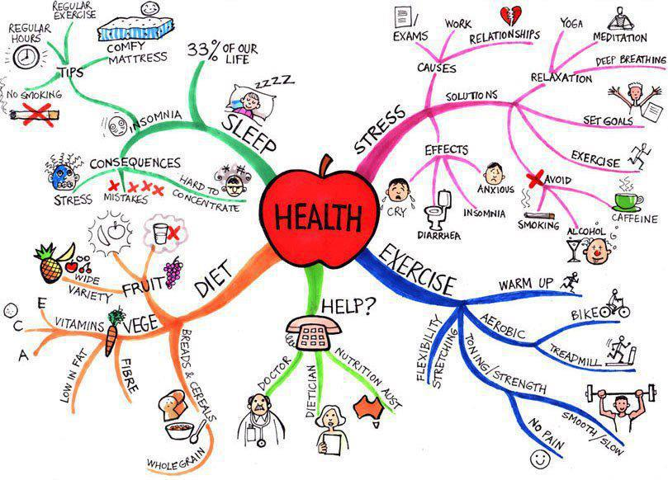
Health:
1. Drink plenty of water.
2. Eat breakfast like a king, lunch like a prince and dinner like a beggar.
3. Eat more foods that grow on trees and plants, and eat less food that is manufactured in plants.
4. Live with the 3 E’s — Energy, Enthusiasm, and Empathy.
5. Make time for prayer and reflection
6. Play more games.
7. Read more books than you did in 2012.
8. Sit in silence for at least 10 minutes each day.
9. Sleep for 7 hours.
Personality:
10. Take a 10-30 minutes walk every day —- and while you walk, smile.
11. Don’t compare your life to others’. You have no idea what their journey is all about.
12. Don’t have negative thoughts or things you cannot control. Instead invest your energy in the positive present moment.
13. Don’t over do; keep your limits.
14. Don’t take yourself so seriously; no one else does.
15. Don’t waste your precious energy on gossip.
16. Dream more while you are awake.
17. Envy is a waste of time. You already have all you need.
18. Forget issues of the past. Don’t remind your partner with his/her mistakes of the past. That will ruin your present happiness.
19. Life is too short to waste time hating anyone. Don’t hate others.
20. Make peace with your past so it won’t spoil the present.
21. No one is in charge of your happiness except you.
22. Realize that life is a school and you are here to learn. Problems are simply part of the curriculum that appear and fade away like algebra class but the lessons you learn will last a lifetime.
23. Smile and laugh more.
24. You don’t have to win every argument. Agree to disagree.
Community:
25. Call your family often.
26. Each day give something good to others.
27. Forgive everyone for everything.
28. Spend time with people over the age of 70 & under the age of 6.
29. Try to make at least three people smile each day.
30. What other people think of you is none of your business.
31. Your job won’t take care of you when you are sick. Your family and friends will. Stay in touch.
Life:
32. Do the right things.
33. Get rid of anything that isn’t useful, beautiful or joyful.
34. Forgiveness heals everything.
35. However good or bad a situation is, it will change.
36. No matter how you feel, get up, dress up and show up.
37. The best is yet to come.
38. When you awake alive in the morning, don’t take it for granted – embrace life.
39. Your inner most is always happy. So, be happy.
Last but not least:
40. Enjoy LIFE!

