VITAMINA D SINTOMAS Y DEFICIENCIAS
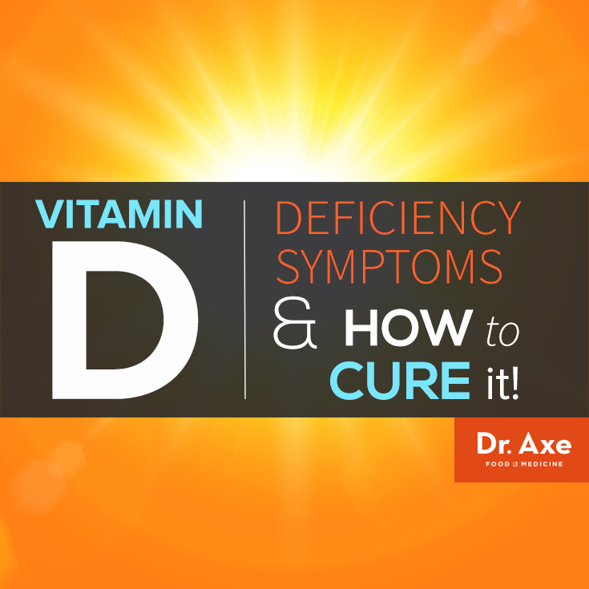
Vitamin D Deficiency Symptoms
Would you believe that the majority of the population- up to 90% of adults in the United States- is believed to have a Vitamin D deficiency? Many physicians are starting to take this vitamin deficiency very seriously; in fact Vitamin D is one of the most recommended supplements by physicians today.
Most adults are believed to be at least somewhat deficient in Vitamin D, however, people with dark skin, who live in northern regions of the world where less year-round sun exposure is experienced, and those who are overweight have an even greater chance to be deficient.
According to the National Health and Nutrition Examination Survey (NHANES), the newest statistics demonstrate that more than 90% of people with darker skin pigments (Blacks, Hispanics, and Asians) living in the United States now suffer from Vitamin D insufficiency, while 75% of the white population is deficient. (1)
As the population of overweight and obese adults and children has risen steadily over the past several decades, so has the incidence of Vitamin D deficiency symptoms. Sadly, this Vitamin D deficiency is correlated with increased risks of developing common cancers, autoimmune diseases, hypertension, and various infectious diseases too. (2)


What is Vitamin D?
Vitamin D is a fat soluble vitamin that is stored in the liver and fatty tissues. This means that increased body fat has the ability to absorb Vitamin D and keep it from being used within our body. Vitamin D is somewhat different than other vitamins because our body makes most of our Vitamin D on its own, rather than solely relying on food sources.
The way that our bodies make Vitamin D is to convert sunshine into chemicals that are used by the body. The cholesterol in our skin converts “previtamin D” and makes it into usable vitamin D3 which is sometimes also called provitamin D (3). Previtamin Ds first travels through the kidneys and liver in the blood stream, and then is converted into a biologically active and usable substance called calcitriol.
Vitamin D actually becomes a hormone within our body, particularly a secosteroid hormone. What we know as Vitamin D is really a precursor to a steroid hormone. It impacts not only our skeletal structure, but also our blood pressure, immunity, mood, brain function, and ability to protect ourselves from cancer. (4)

Vitamin D2 vs. Vitamin D3
There are two types of supplemental Vitamin D: Vitamin D2 and Vitamin D3. The precursor to Vitamin D is found in both plant and animal products, but animal-derived products of Vitamin D3 are thought to be more absorbable and beneficial.
Why? Well, man-made Vitamin D is made one of two ways: D2 is created by irradiating yeast and other molds (known as Vegetarian Vitamin D2), or by irradiating animal oils and cholesterol creating Vitamin D3. The type of Vitamin D our body naturally makes is called cholecalciferol, which is Vitamin D3.
The body is able to covert some D2 to be used for body functions, but prefers and is able to use Vitamin D3 much more effectively.
Unfortunately, most Vitamin-D-fortified foods and dietary supplements mostly contain ergocalcifero, which is a type of Vitamin D2 which is neither as absorbable nor convertible by the body into what it needs.
D3 from animal products (specifically from the cholesterol within these products) is closest to what sunlight naturally produces in humans when the skin works to convert UV light.
Vitamin D3 is believed to convert up to 500 times faster than D2 and has been estimated to be 4X more effective in humans than D2 is.

Sunshine and Vitamin D Deficiency Symptoms
Many people assume that the best way to acquire Vitamin D is through drinking milk, eating fish, or even taking supplements like cod liver oil. However direct exposure to the sun is actually the best way to absorb Vitamin D. (5)
In fact, the reason our skin darkens is partially due to Vitamin D. If you sit in the sun unexposed, without sunscreen for roughly 10 minutes, you are likely absorbing about 10,000 units of natural Vitamin D- however keep in mind this amount differs from person to person depending on their skin tone.

How Our Bodies Get Vitamin D From the Sun
Melanin is a substance that affects how light or dark your skin color is; the more melanin you have in your body, the darker your skin color. The amount of melanin you have in your skin affects the amount of vitamin D you can produce; the fairer your skin, the more easily you can make Vitamin D.
Melanin gets released when we are exposed to the ultraviolet rays of sunshine. The more sunshine we receive, the more melanin is released in our skin. It’s believed that up to 90 to 95% of most people’s Vitamin D comes from casual sunlight exposure.
The cholesterol in the skin converts melanin into usable Vitamin D to be distributed throughout the body. This is why for many people, a slight to moderate rise in cholesterol level can be experienced in the winter months when there is are less exposure to sunshine, since it’s common to spend much more time indoors.

How Much Sun is Enough?
Most experts recommend getting about 10-15 minutes daily of direct sunlight without wearing sunscreen if you are fair to medium toned. If you have dark skin, you will likely need more time in the sun to make enough Vitamin D since your skin has more protection against the sun’s effects.
Some experts recommend that darker toned people spend about 40 minutes to one hour in the sun daily if possible. If you live farther from the equator (in the US this would be the mid-states or farther north), then you will need more time overall in the sun (closer to the hour time-frame). Or if in winter, you will need to double the recommended time to allow enough Vitamin D production to occur.
Here is a good rule of thumb to know that the sun is creating Vitamin D in your skin: you want to look at your shadow and see that it’s shorter than you are; this will tell you that the sun is high enough in the sky and strong enough to convert Vitamin D in your skin.
So for example, you may experience this during the hours of 10am-3pm, but not as much during other times of the day when the sun is lower and therefore less likely to penetrate your skin effectively.
If you are worried about not wearing sunscreen and fear the effect that direct sunlight can have on your skin, then try applying sunscreen to your face and hands, but not on your limbs (assuming your limbs are exposed). This will leave enough unexposed skin to properly create the Vitamin D that you need.

Vitamin D Deficiency Symptoms & Causes
It’s worth repeating that roughly up to 90 to 95% of most people’s vitamin D comes from casual sunlight exposure. Your skin makes Vitamin D when it comes in contact with the ultraviolet B (UVB) rays from the sun. Therefore one of the biggest reasons that a growing population is experiencing Vitamin D deficiency symptoms is because of our modern, primarily indoor lifestyle. This contributes to the two most common causes of Vitamin D deficiency symptoms:
1. Lack of Sun
While years ago people spent more time outdoors, walking to do errands and even working outside, today we see a different situation. Most children are spending unprecedented hours inside; watching television, playing video games, surfing the internet etc. And similarly, most adults work indoors, exercise inside gyms, and spend their free time inside their homes where they are sheltered from the sun.
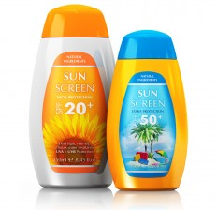
2. Sunscreens
On top of this, when we do spend time in the sun, many of us are wearing sunscreen nearly the entire time. As the risk for developing skin cancer has also risen in recent years, doctors are strongly encouraging the use of sunscreen for children and adults, even through the winter months and when sun exposure is generally limited.
Alarmingly, some research shows that when you wear sunblock SPF 8, you reduce your body’s ability to make vitamin D by 90%. If you choose a sunblock with a higher SPF of 30 (which is the number normally recommended by doctors), you reduce your body’s ability by up to 99%. This results in further deficiencies because the time we do spend outdoors does not equate to our bodies converting Vitamin D from the sun when we wear sunblock.

According to research, a Vitamin D deficiency symptoms can be linked to the following health problems:
Osteoporosis
Heart disease
High blood pressure
Cancer
Autoimmune diseases
Depression
Insomnia
Arthritis
Diabetes
Asthma
Multiple Sclerosis
Chronic pain
Psoriasis
Fibromyalgia
Autism
The only way to know if you are deficient in Vitamin D is to have your doctor perform a test. This will tell you if, and how severely, you are deficient.
When your doctor performs a blood test and gives you the results for your Vitamin D levels, keep these numbers in mind:
50+ equals a good level of Vitamin D
30-50 means that you will want to be supplementing Vitamin D, working on spending more time in the sun and adding in Vitamin D rich foods to your diet.
<30 means that you are very deficient and you will definitely want to take immediate action to bring those levels up!
Talk with your doctor about supplementing with higher doses of Vitamin D if you are severely deficient or have a very low level according to tests done. When your doctor performs a Vitamin D test, specify that you would like to have the 25-hydroxoyvitamin D test done, sometimes also called the 25(OH) D test.
Some other types of Vitamin D tests can show normal or even elevated levels of Vitamin D which are actually inaccurate and can hide a serious deficiency, so this type of test seems to be the most accurate when determining Vitamin D levels.

Top Vitamin D Sources
While some foods provide Vitamin D, exposure to sunlight is still the very best way to get the Vitamin D you need. However eating foods that are rich in Vitamin D certainly also helps you to acquire more, so try adding good-quality, natural sources into your diet regularly.
Top 16 Sources of Vitamin D (according to the USDA):
1) Sunlight
Aim for spending 10-20 minutes of unexposed time in the sun daily (between 1,000 and 10,000IU). The range is so wide as it is dependent on what time of year, how far from the equator you live, and how much skin is exposed. If you have lighter skin, then less time is needed. If you have darker skin or live farther north ( in the northern hemisphere – like Boston), then you would need about an hour of sun in summer to get about 1000IU of Vitamin D.
2) Halibut
3 0z. filet: 932 IU
3) Carp Fish
3 oz. filet: 940 IU
4) Mackerel
1 piece: 805 IU
5) Eel
3 oz.: 792 IU
6) Maitake Mushrooms (Exposed to UV light)
1 cup sliced: 786 IU
7) Salmon
3 oz. filet: 730 IU (or 1 3 oz. can has 718 IU)
8) Whitefish
1 cup mixed and shredded: 696 IU
9) Portabella Mushrooms (Exposed to UV Light Exposure)
1 cup sliced: 634 IU
10) Swordfish
3 oz. filet: 556 IU
11) Rainbow Trout
3 oz. filet: 539 IU
12) Cod Liver Oil
1 tsp: 450 IU
13) Sardines
1 can (3.75 oz): 178 IU
14) Tuna
1 can (3 oz.) packed in water: 148 IU
15) Eggs
1 large whole egg: 41 IU
16) Raw Milk
1 quart: 38 IU (or about 9 IU per cup)


Vitamin D in Mushrooms
Mushrooms are a very interesting and rare food when it comes to Vitamin D. They are one of the only plant sources of Vitamin D and actually act similarly to how human skin does, absorbing more Vitamin D when exposed to the sun. In some mushrooms that are now available in certain health food stores, the Vitamin D content is being boosted by exposing these mushrooms to ultraviolet light.
Mushrooms contain plant sterols which are able to convert UV light to vitamin D. Exposing mushrooms to as little as five minutes of UV light is believed to produce a substantial amount of vitamin D (6). While mushrooms are typically grown indoors, many growers are beginning to grow them outdoors to take advantage of this, or to place the growing mushrooms under sunlamps.
Rare and sometimes difficult-to-find maitake mushrooms for example contain a huge amount of Vitamin D, while portabella and other varieties also make good sources but are not nearly as high. You can ask the workers at your health good store, or the farmers at your local farmer’s market, if their mushrooms were grown indoors or outdoors in order to know if the mushrooms you are purchasing will contain higher amounts.

Vitamin D in Pasteurized Milk and Raw Milk
Interestingly, and despite what many people think, regular pasteurized milk does not naturally contain much Vitamin D at all. Synthetic Vitamin D is actually added to pasteurized cow’s milk, soy milk and rice milk.
Almost all of the U.S. milk supply is fortified with 400 IU of vitamin D per quart according to the USDA. But foods made from milk, like cheese and ice cream, are usually not fortified. Synthetic Vitamin D that is added to foods is believed to be much less effective as naturally occurring Vitamin D and can also potentially block natural Vitamin D’s effects. (6)
Raw milk on the other hand is believed to contain a small amount of Vitamin D naturally which is found its in fat and not destroyed during pasteurization. Some sources show that raw milk has about 38 IU of Vitamin D per quart (4 cups).
However it’s hard to know for sure how much Vitamin D is in raw milk because it differs a lot depending on the specific milk being tested and correlates with the the health of the animal that it came from.
On top of this, the USDA does not list the official Vitamin D content of raw milk and many sources claim different amounts of Vitamin D to be present within raw milk. So keep in mind that the amount may vary a lot.
The reason that raw milk is thought to be a better source of Vitamin D than pasteurized milk is because unpasteurized (raw) milk is usually superior in almost every vitamin and mineral overall. Raw milk normally comes from cows that are free to graze outside and to eat their natural diet of grass, as opposed to being force fed grains and living indoors. Because the animal is healthier, so is their milk.
A lot of the nutrients that are in regular milk are also destroyed during the high heat pasteurization process. Therefore it seems logical that higher quality raw milk would have more Vitamin D to begin with and also to retain more of it since it does not go through a high-heat pasteurization process.

Top 7 Health Benefits of Vitamin D
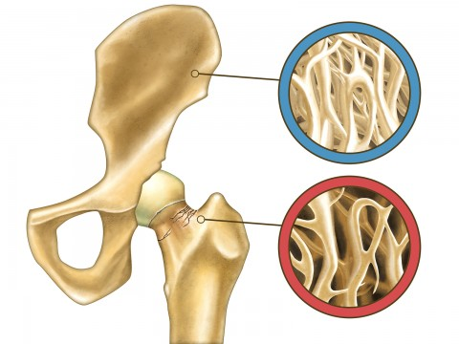
1. Contributes to Bone Health
Vitamin D plays a role in calcium absorption into the bones. Calcitriol (converted Vitamin D) works with the parathyroid hormone to maintain calcium levels. Additionally, Vitamin D has an effect on other important vitamins and minerals that contribute to both health including Vitamin K and phosphorus.
Vitamin D is partially responsible for maintaining phosphorous levels in the blood and since Vitamin D affects the ability of calcium to bind to proteins, it is believed that it is also linked to Vitamin K.
A deficiency in Vitamin D can result in a softening of the bones called osteomalacia, or a bone abnormality called rickets. Additionally, a deficiency increases the risk for developing osteoporosis and experiencing fractures or broken bones.
Studies have shown that Vitamin D in doses of 800-5000 IU/day can improve musculoskeletal health, naturally slow aging of the skeletal structure, and reduce the rate of fractures and falls in older adults that are over 65. (7) Older adults with adequate vitamin D levels are more likely to be active, have improved muscle strength, and are less prone to falls and injuries.
When vitamin D levels are low, the parathyroid becomes overactive. This is known as hyperparathyroidism and results in drops in phosphorous. Phosphorus, in addition to calcium and other compounds, is needed in order to properly mineralize bone density.

2. Helps Manage Blood Sugar Levels and Can Prevent Diabetes
Diabetes results from lack of insulin or inadequate insulin secretion following increases in insulin resistance. According to studies, since calcium is necessary for insulin secretion, Vitamin D may contribute to maintaining insulin secretion. (8)
Vitamin D supplementation can increase insulin sensitivity and decrease inflammation, and studies support a role for Vitamin D in the prevention and management of both types of diabetes (type 1 and type 2). (9)


3. Protects Against Cancer
Vitamin D deficiency symptoms have been correlated with increased risks for cancer development, especially breast, colon, and prostate cancers. (10) Vitamin D can affect the risk of breast, colon and ovarian cancers possibly due to its role in the cell life cycle or its ability to block excess estrogen. (11)

4. Helps Fight Heart Disease
A growing number of research points to the fact that a Vitamin D deficiency is linked to increased risks for cardiovascular disease, since it is involved in regulating blood pressure, cholesterol levels, and inflammation.
According to the latest studies, it is still unclear if Vitamin D can help prevent heart disease, heart attack, and stroke, but we do know that people who are deficient are more likely to die from coronary heart disease and other heart related symptoms.


5. Enhances Our Immune System
Vitamin D helps with healthy cell replication and may play a role in protecting against the development of autoimmune conditions in addition to less serious common colds and the flu.
Our immune cells contain receptors for Vitamin D, and it’s been shown that Vitamin D seems to prevent prolonged or excessive inflammatory responses. Inflammation is often at the root of many modern, chronic diseases and autoimmune disorders: multiple sclerosis, rheumatoid arthritis, irritable bowel syndrome and other digestive disorders, high blood pressure, and more. (12)

6. Facilitates in Hormone Regulation and Helps Improve Our Mood
Because it acts like a hormone within our body and effects brain function, Vitamin D deficiency has been linked to an increased risk for mood disorders including depression, seasonal depression (known as the “winter blues” but actually more serious), severe mood problems experienced during PMS, insomnia, and anxiety. (13)
Low levels of Vitamin D can also interfere with proper testosterone and estrogen production, leading to imbalances which can result in many unwanted symptoms.


7. Helps with Concentration, Learning, and Memory
Several studies have shown that Vitamin D also effects our ability to making decisions, concentrate, and to retain information. Some studies have shown that people with lower levels of vitamin D perform poorly on standardized exams, may have poor decision making skills, and have difficulty with tasks that require focus and attention. (14)
Additionally, some research has shown a correlation between low levels of Vitamin D and an increased risk for developing schizophrenia and multiple sclerosis.

Recommended Daily Intake of Vitamin D
Because Vitamin D deficiency symptoms are a growing concern worldwide, but especially in western developed nations, authorities recently increased the recommended daily intake of vitamin D to double the previous amount for newborns, kids, and adolescents.
The RDA for Vitamin D according to the USDA is 600 IU/day for adults. I personally recommend getting 5000 IU/day, especially since there is little risk in over-supplementing with Vitamin D, but many benefits to gain from having adequate levels.
However keep in mind that this is a general recommendation and there is no way to know the exact amount that’s best for you without a blood test. You may need a higher or lower amount and should speak to your doctor if so, this way you can purchase a good-quality, food based vitamin in the proper dose you need right away.
For example, some studies have shown that in patients with documented Vitamin D deficiency, a very high, cumulative dose of at least 600,000 IU administered over several weeks appears to be necessary to replenish stores within the body. (15) Ideally you want to supplement with a high quality, whole food based multi-vitamin or Vitamin D supplement until your blood level of Vitamin D is between 50-60 ng/ml.
My Recommendation for Children:
Below 5: 35 units per pound/day
Ages 5-10: 2500 units/day
My Recommendation for Adults (including pregnant women):
5000 units/day
However to be clear, below is the USDA’s official recommendation of Vitamin D (15):
Children:
1 – 3 years: 600 IU (15 mcg/day)
4 – 8 years: 600 IU (15 mcg/day)
Older children and adults
9 – 70 years: 600 IU (15 mcg/day)
Adults over 70 years: 800 IU (20 mcg/day)
Pregnancy and breast-feeding: 600 IU (15 mcg/day)
Certain supplements do provide the preferred type of Vitamin D3. You will want to look for a supplement that provides the actual food source of the vitamin, along with all of the other enzymes and compounds that naturally help us to utilize it. This makes it more effective than the isolated vitamin alone.

Vitamin D Interactions and Concerns
Luckily your skin is able to regulate Vitamin D conversion according to heat and other factors. It can store pre-vitamin D for future use, and destroy amounts above and beyond what is safe. So deficiency is usually a much bigger concern than consuming too much Vitamin D.
Because Vitamin D is a fat soluble vitamin, it ideally needs to be consumed with fat in order to have optimal absorption. If you are going to eat a food source of Vitamin D, it’s best to combine it with some more of essential fat source too, like ghee, coconut oil, nuts, seeds, or fish.
Vitamin A and Vitamin D have an important relationship. Some studies have recently suggested that there is a possibility for Vitamin D deficiencies to become worse when a person takes a high supplemental intake of vitamin A.
These studies reveal that when blood levels of vitamin D fall below 50 on a Vitamin D blood test (which means the person is nearing deficiency), higher supplemental intake of vitamin A can worsen the problem.
The good news is that when Vitamin A and D levels are both sufficient, research has shown that they work together to help your body metabolize the vitamins and use them to their best ability. Supplementing with very high doses of Vitamin A is not recommended therefore if you have a known Vitamin D deficiency and can lead to certain problems.

Were any of the Vitamin D deficiency symptoms surprising to you?
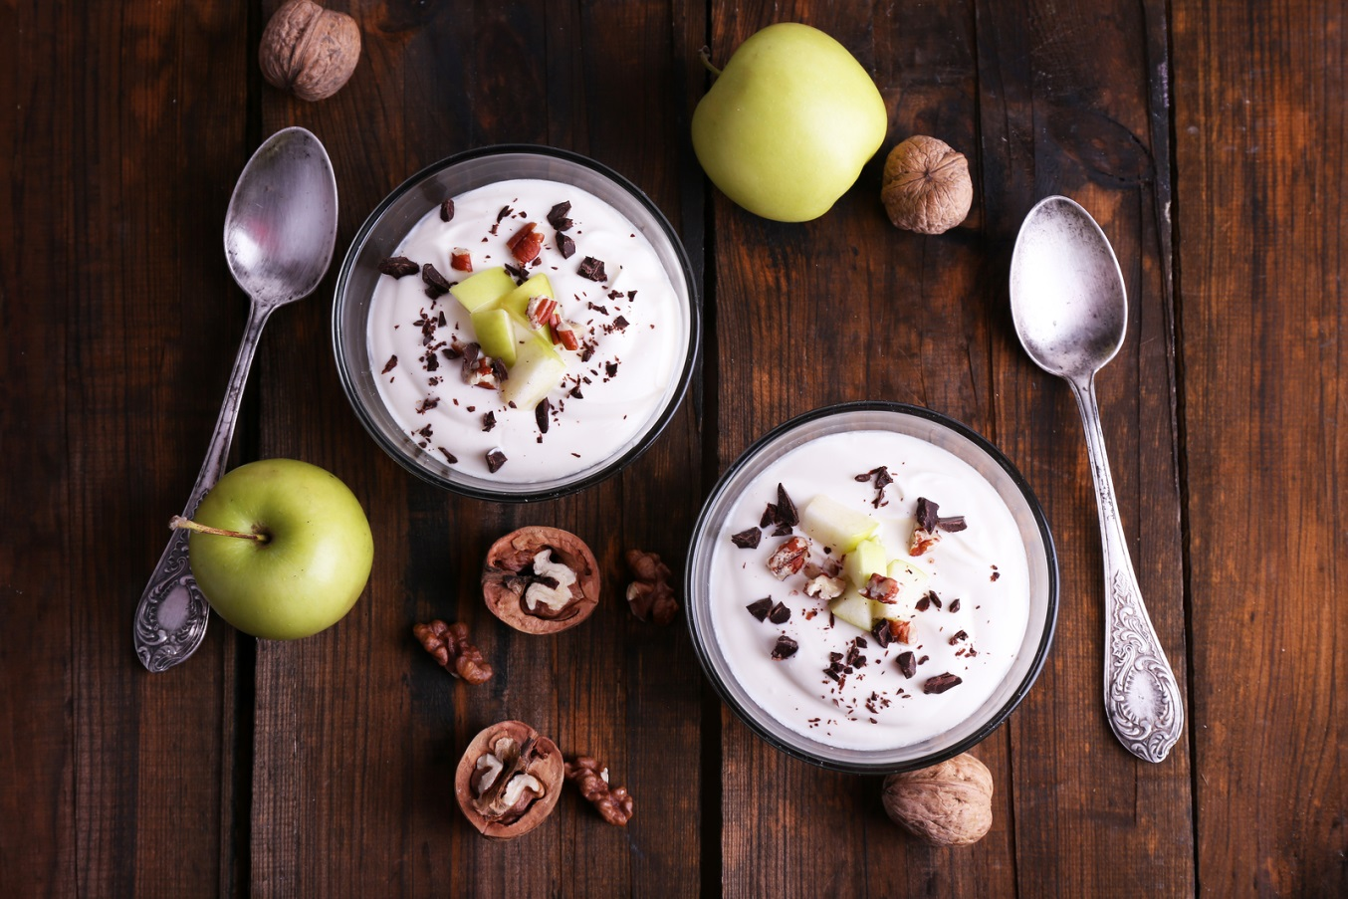
10 Proven Probiotic Yogurt Benefits & Nutrition Facts

Vitamin K Deficiency, Foods & Health Benefits
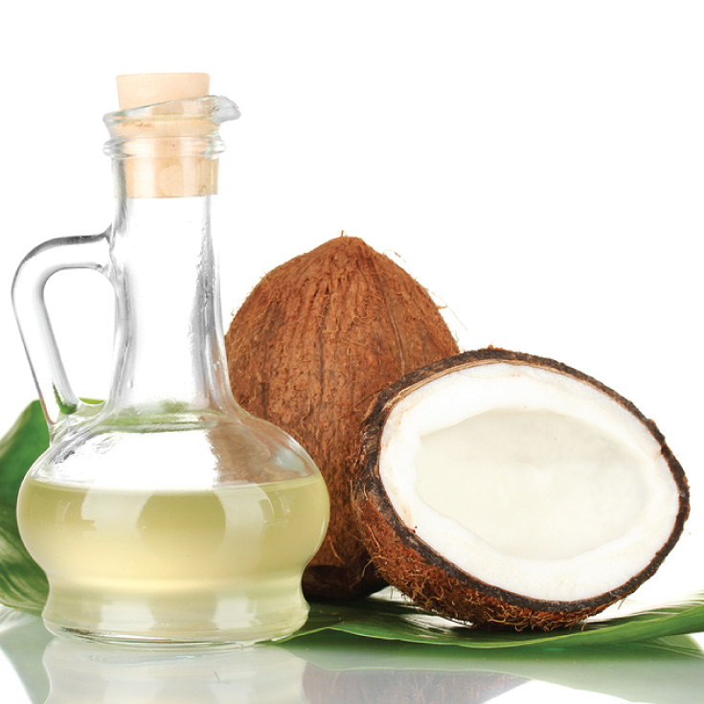
20 Coconut Oil Benefits & Side Effects (#5 is Life Saving)
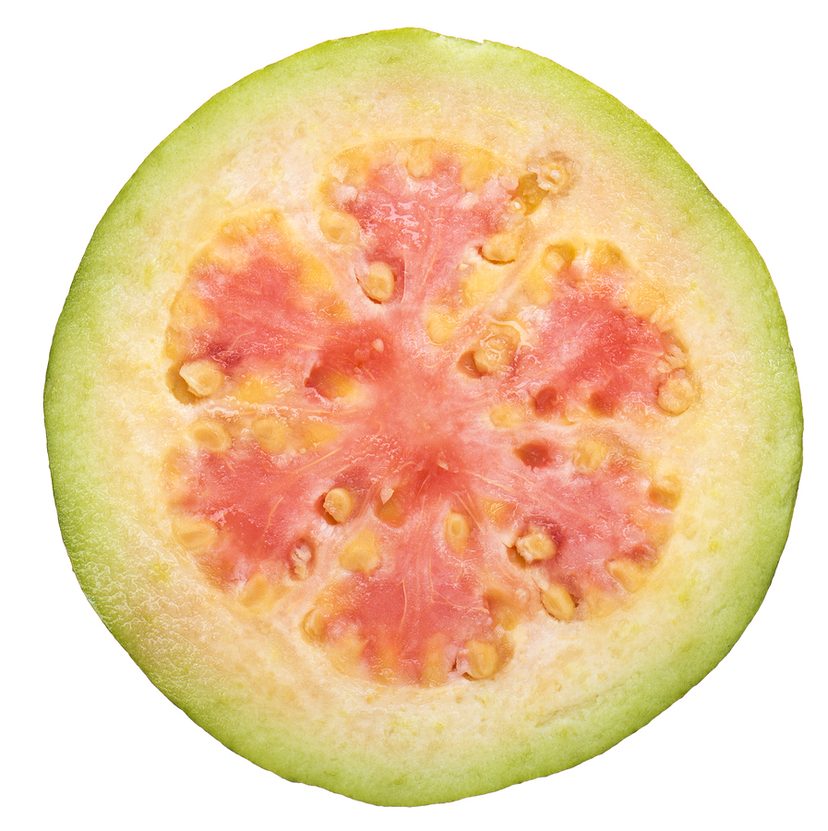
Vitamin C Foods, Signs of Deficiency, & Health Benefits
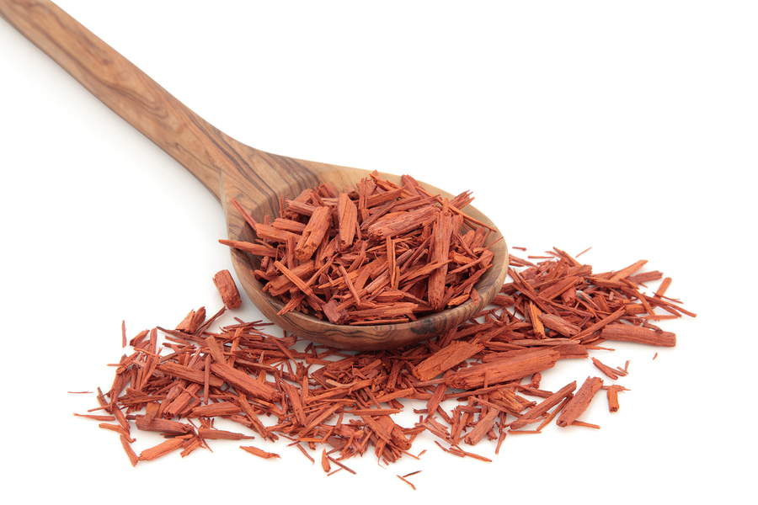
Sandalwood Essential Oil Benefits & Uses

9 Candida Symptoms & 3 Steps To Cure It
Most Popular
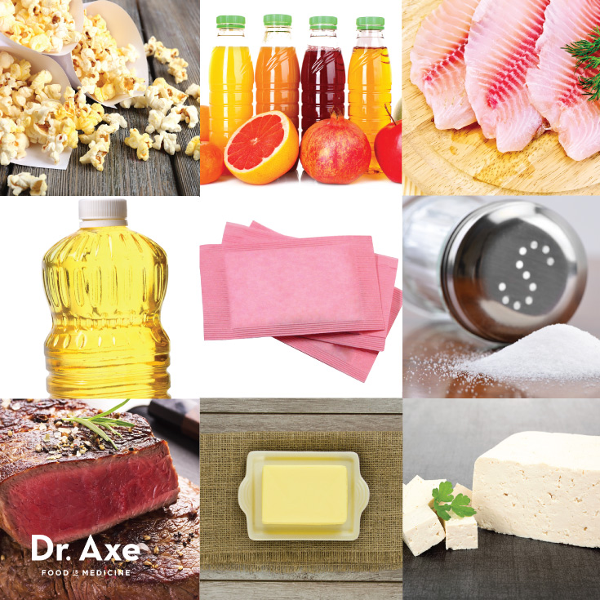
10 Health Foods You Should Never Eat
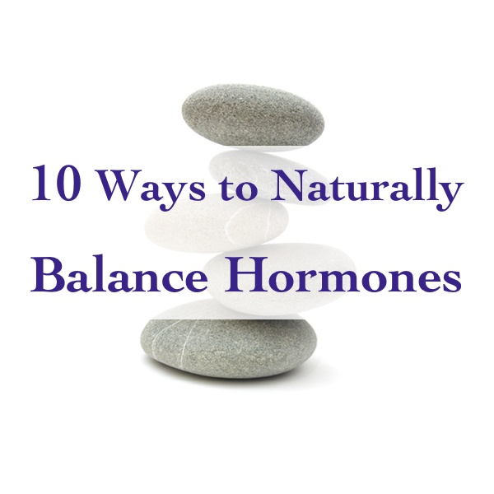
10 Ways To Balance Hormones Naturally
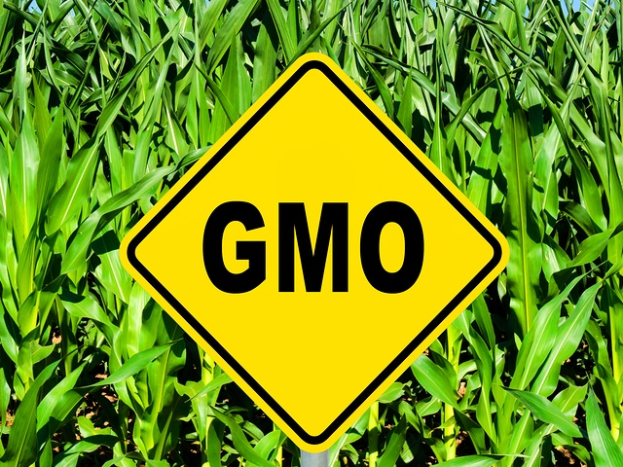
Genetically Modified Foods (GMO) Linked to Tumors, Allergies and Early Death

Bone Broth Benefits for Digestion, Arthritis, and Cellulite

4 Steps to Heal Leaky Gut and Autoimmune Disease

All About Resveratrol
19 comments so far - add yours!
Grace@nourishwithwholefoods(Instagram) says:
February 10, 2015 at 12:10 pm
Thanks for sharing this with us Dr.Josh Axe. I’m a holistic nutritionist by trade and this information is so valuable. Thank you for the time spend on this and I will make sure to pass it on to all who are willing to listen. Blessings xo
Reply
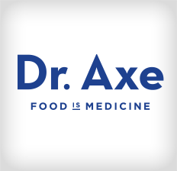Luis says:
February 9, 2015 at 10:38 pm
lfe.org or life extension website offers blood testing for vitamin D 25(OH)D without a doctor and is a lot less expensive. Bio-Tech offers 50000 IU of vit D if you are in the lower range (just one pill once a week) then 10000 units after for at least six months to bring levels above 50. Make sure to test after six months or earlier, but every person is different so do your research please.
Reply
Timothy says:
February 9, 2015 at 8:46 pm
Dr axe I ran across this vitamin d issue and have an unrelated question concerning hep c can you direct me to the proper q&a forum or may I ask it here
Reply
Dr. Josh Axe says:
February 10, 2015 at 10:28 am
You can ask questions here! We have a great community. I try to get to as many questions as I can but am not always able to do so. Our community is amazing and extremely helpful with lots of information and is great about helping with answers as well!
Reply
Donna Marie says:
February 9, 2015 at 7:52 pm
Whoo-hoo! Thank you so much for this article on Vitamin D. My doctor ran blood test on me last year and said everything was fine except for my Vitamin D level, it was very low!! I’ve had problems with Vitamin D in the past, I would break out in hives after taking them for 2 weeks. This time I went to the health food store and the clerk suggested “plant based” Vitamin D. I purchased it back in the beginning of January and I’ve been taking it since with no problems and I feel great! I have to go back in 12 weeks for another blood test and I’m actually looking forward to it! It’s good to know that the supplement is good in fighting against cancer. I am a 8 year breast cancer survivor!
Reply
Dr. Josh Axe says:
February 10, 2015 at 10:29 am
Wow, that’s awesome Donna!a
Reply
David says:
February 9, 2015 at 7:32 pm
Dr. Axe. I read somewhere that the angle of the sun in the sky must be > 50 degrees in order for the light, that is the correct wavelength that produces vitamin D to get thru the atmosphere. In other words, the reason you want to get midday sun, is that it is at a high enough angle then to allow the right light to hit your body, which will allow you to produce Vit D. Is this true? Is the 50 degree figure accurate?
Reply
Ken says:
February 9, 2015 at 4:59 pm
Hi,I live in Nova Scotia Canada so I see very little sun that is high enough to produce vitamin D in the skin.I joined the “D Action” project in the US and get my blood test done by them each 6 months.It took 5 years of increasing from 5,000 to 6,000 to 8,000 to 10,000 and now to 12,000 IU an average of 5 days a week to reach a level of 41 ng/ml.To me a recommended dose of 600 IU a day is ridiculous if living in the northern hemisphere.Doctors in this province will refuse to do a D test because as they say “everyone is deficient” and the test costs too much.Well,how are we to know how deficient?This is why I joined your(US) “D Action” project,my starting level was 30 ng/ml and is now 41 ng/ml so progress is being made.Can be around people with colds,flu,etc. and do not get sick so can only imagine how much better it can get at 60 ng/nl.Ken
Reply
Nicola says:
February 9, 2015 at 4:06 pm
Do you have a reference for (14). Link not there and I’m curious to read more. Thanks!
Reply
Dr. Josh Axe says:
February 9, 2015 at 5:20 pm
The link should be fixed now. Thanks for letting me know!
Reply
Bianca says:
February 9, 2015 at 4:05 pm
Good post, Dr. Axe.
I don’t believe in sunscreen and I question all the “hype” about Vit. D. supplementation. It’s someones opinion.
I agree with your “sunlight exposure” as being the very best source and the most natural. I also like your food suggestions.
However, I wonder why no one questions the reasons why Vit. D levels are low in most people. Is it our Low-fat diets ?
(I do not subscribe to low-fat diets either) what’s missing ?
Since Vit D is fat soluble (which I remind people of very often) it’s important to have good fats in the diet.
I also highly rec. sardines which in my immigrant background were highly appreciated and essential.
Your recipes are super and enjoyed !
Thank you :)
Reply
Dr. Josh Axe says:
February 9, 2015 at 4:47 pm
I agree! Good fats are so important in the diet in addition to getting vitamin D from natural sunlight!
Reply
Dr. Michael L. Smith says:
February 9, 2015 at 3:40 pm
I would suggest that you read, “Inflammation and vitamin D: the infection connection.” M. Mangin et al Inflamm. Res. (2014) 63: 803-819.
“There is strong evidence for the use of 25(OH)D as well as testing for 1,25 (OH)2D especially in individuals exhibiting chronic inflammation as a result of persistent intracellular pathogens and stealth infections. Elevated 1,25 (OH)2D often accompanied by reduced 25(OH)D is a clinical sign of dysregulated Vit. D metabolism and evidence that the immune system is competing with parasitic microbes for VDR dominance. Avoidance of elevating 25(OH)D can improve this scenario. ”
In patients exhibiting low 25(OH)D, abnormal inflammatory markers, a diagnosis of autoimmune disease or other chronic inflammatory diseases or signs of chronic systemic inflammation the 1,25(OH)2D should be measured.
Reply
Nicola says:
February 9, 2015 at 3:21 pm
Typo on cholecalciferol paragraph 9. Missing ‘l’
Reply
Dr. Josh Axe says:
February 9, 2015 at 4:49 pm
Thanks for letting me know!
Reply
Leave a Reply Cancel reply
Principio del formulario
Your email address will not be published. Required fields are marked *
Name *
Email *
Comment
You may use these HTML tags and attributes: <a href="" title=""> <abbr title=""> <acronym title=""> <b> <blockquote cite=""> <cite> <code> <del datetime=""> <em> <i> <q cite=""> <strike> <strong>


<p><strong>Please note:</strong> JavaScript is required to post comments.</p>
Final del formulario
Principio del formulario

Get FREE ACCESS →
To my FREE eBook, 30 Gluten-Free Recipes & Shopping Guide!

I'm interested in...
Healing Foods
Natural Remedies
Healthy Recipes
Fitness / Metabolism
All of the Above


Final del formulario
Inside Dr. Axe
Articles
Videos
Contact Dr. Axe
Media Inquiries
Press Room
Start Here
Special Reports
Healthy Resources
Success Stories
Topics
Gut Health
Weight Loss
Essential Oils
Hormone / Thyroid
Non-GMO
Cancer
Nutrition
Top 10 Lists
Natural Cures
DIY Recipes
Products
Green Superfood
BurstFIT DVD
Grass-Fed Whey Protein
Real Food Diet Cookbook
Probiotics
Real Food Multivitamin
Fish Oil + Vitamin D
Privacy Policy
Terms of Use
Affiliate Disclosure
DMCA Policy
* These statements have not been evaluated by the Food and Drug Administration. This product is not intended to diagnose, treat, cure or prevent any disease. If you are pregnant, nursing, taking medication, or have a medical condition, consult your physician before using this product.
© 2015 DrAxe.com
Site by Kymera
Scroll
×
Enter Your Email Below
Free Cheat Sheet: "The Healing Food Shopping List"
"Simple and easy to use...
I know exactly what foods to buy
for optimal health"
- Sharon H


You're awesome, you'll hear from us shortly!
Principio del formulario
Like what you’re reading? Get FREE updates sent to your inbox.
Yes, I'm In!
Final del formulario
<img height="1" width="1" alt="" style="display:none" src="https://www.facebook.com/tr?id=676615992413367&amp;ev=PixelInitialized">

