Garlic And Lemon – Powerful Remedy Against Cancer !
Posted By HealthyFood On Friday, June 13, 2014 12:01 AM. Under Health

This cure cleanses the body, especially the blood vessels, making them resilient. It is used for high cholesterol, elevated triglycerides, and prevention of heart attacks, stroke, and angina pectoris. The cure made of lemon and garlic improves vision and is a great prevention and cure of cancer.It protects and rejuvenates the body and is excellent for longevity. –

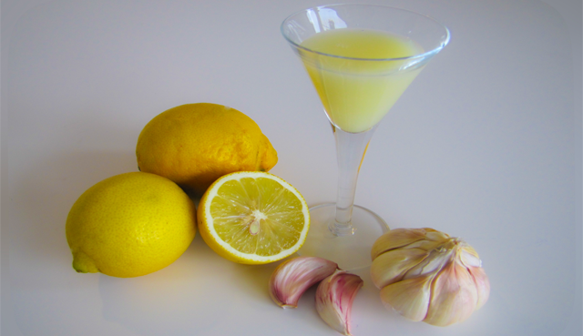

Preparation
- 300 gr garlic
- 1 kg. lemons
- 1.5 liters water
Chop the lemons and garlic finely (or put it in a blender to grind), then place them in boiling water and boil for 15 minutes on low heat. Leave the liquid to cool well, and then store it in a sealed glass container (jar).

How to use
Drink the liquid in the mornings before breakfast on an empty stomach. The daily dose is 50 ml. in a period of 25 days. Then pause 10 days, and if needed repeat the treatment with another dose. The pause of 10 days is necessary, as well as the daily amount of 50 ml.
If you drink two doses with a break between them, do not use the cure longer period of time, unless of worsening health condition.
Those who do not have health problems can use this cure to improve the general health, preserving health and longevity. For this purpose the cure should be used 2 times a year, every six months, again for a period of 25 days.
- See more at: http://www.healthyfoodteam.com/garlic-and-lemon-powerful-remedy-against-cancer/#sthash.O2Ox0j3r.dpuf

