Daniel Fast: Benefits, Food List and Breakthrough Secrets
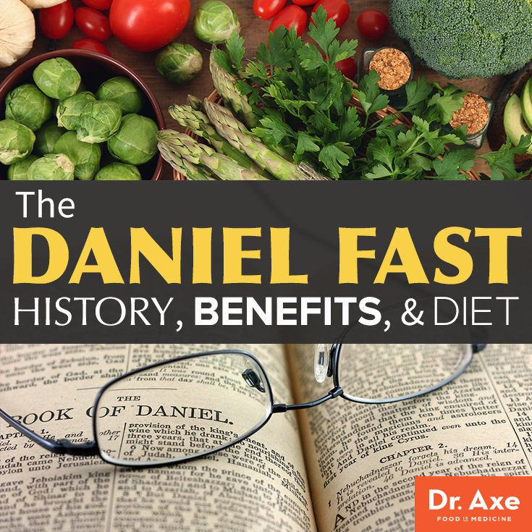

The Daniel Fast
I want to introduce you to a secret healing therapy that can take your spiritual, physical and emotional health to a whole new level…it’s called the Daniel Fast and it includes many Bible foods that support healing.
Fasting is a natural discipline that can bring supernatural results.
And, Fasting works when nothing else will.
Moses, Elijah, Esther, Ezra, Job, David, Daniel, Peter, Paul even Jesus…fasted.
The Bible is filled with more than 70 references to fasting, but over the last several decades fasting has disappeared from the church and is only beginning to make a resurgence today.

What is a fast?
Fasting is abstaining from something like food, drink or entertainment for a period of time to create some type of benefit in body, mind or spirit.
There are many types of fasts which include:
-Standard Fast (water only)
-Absolute Fast (No water or food)
-Partial Fast (restrict certain food and drink categories)
-Intermittent Fast (Only eat during small daily window, for example: 1pm-6pm)
There are many variations of these fasts, and there are spiritual benefits of all of these, when we are able to devote the time spent eating to focus on God and serving others.
If you are looking for a healing breakthrough in body, mind and/or spirit, then you may consider doing a Daniel Fast.

What is a Daniel Fast?
The Daniel Fast is a biblically based partial fast referenced in the Bible, particularly in two sections of the Book of Daniel:
- Daniel 1:12, which states, “Please test your servants for ten days, and let them give us vegetables [pulses] to eat and water to drink.”
- Daniel 10: 1-2, which says, “In those days I, Daniel, was mourning three full weeks. I ate no pleasant food, no meat or wine came into my mouth, nor did I anoint myself at all, till three whole weeks were fulfilled.”

Daniel Fast: Food List
According to our understanding of the Hebrew definition of “pulse” that was used in the verse for vegetables can actually mean a range of foods. Here is the Daniel Fast Food List of what you are allowed to eat:
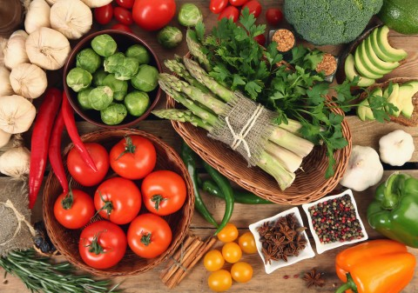
BEVERAGES
- Water only-must be purified/filtered and spring or distilled water is best.
- Homemade Almond milk, coconut water, coconut kefir and vegetable juice
VEGETABLES (should form the basis of the diet)
- Fresh or cooked
- May be frozen and cooked but not canned
FRUITS (consume in moderation 1-3 servings daily)
- Fresh and cooked
- May be dried like raisins or apricots (no sulfites or added oils or sweeteners)
- May be frozen but not canned
WHOLE GRAINS (consume in moderation and ideally sprouted)
- Brown Rice, Quinoa, Millet, Amaranth, Buckwheat, Barley cooked in water
- No Wheat, ezekiel bread, others bread, flours, or pasta
BEANS & LEGUMES (consume in moderation)
- Dried and cooked in water
- May be consumed from can as long as no salt or other additives are contained and the only ingredients are beans and water
NUTS & SEEDS (sprouted are best)
- Raw, sprouted or dry roasted (no salt added)

COMMON FOODS for Daniel Fast
Here is a list of some common foods you can consume in the Daniel Fast:
FRUITS (preferably organic and fresh or frozen):
Apples
Apricots
Avocados
Bananas
Blackberries
Blueberries
Cantaloupe
Cherries
Coconuts
Cranberries
Dates
Figs
Grapefruit
Grapes
Guava
Honeydew melons
Kiwi
Lemons
Limes
Mangoes
Melons
Nectarines
Oranges
Papayas
Peaches
Pears
Pineapples
Plums
Prunes
Raisins
Raspberries
Strawberries
Tangerines
Watermelon

VEGETABLES (preferably organic and fresh or frozen):
Artichokes
Asparagus
Beets
Broccoli
Brussel sprouts
Cabbage
Carrots
Cauliflower
Celery
Collard greens
Corn
Cucumbers
Eggplant
Green beans
Kale
Leeks
Lettuce
Mushrooms
Mustard greens
Okra
Onions
Parsley
Peppers
Potatoes
Radishes
Rutabagas
Scallions
Spinach
Sprouts
Squash
Sweet potatoes
Tomatoes
Turnips
Yams
Zucchini

LEGUMES (preferably organic):
Black beans
Black-eyed peas
Kidney beans
Lentils
Mung beans
Pinto beans
Split peas

NUTS & SEEDS (preferably organic, raw, unsalted and soaked/sprouted):
All nuts (raw, unsalted)
Almonds
Cashews
Chia seed
Flaxseed
Pumpkin seeds
Sesame seeds
Sunflower seeds
Walnuts

WHOLE GRAINS (preferable organic):
Amaranth
Barley
Brown rice
Millet
Quinoa
Oats (groats soaked)

LIQUIDS
Water (spring, distilled, filtered)
Vegetable juice (fresh pressed)
Coconut milk
Coconut Kefir
Almond Milk

FOODS TO AVOID
On the Daniel Fast, you should not consume any of the other foods or beverages listed below. And, I want to mention that on the Daniel Fast some allow sea salt or himalayan salt and others do not. My recommendation is to only use a bit of sea salt when necessary in flavoring dishes. Here are foods you definitely want to refrain from eating:
- Iodized Salt
- Sweeteners
- Meat
- Dairy products
- Breads, pasta, flour, crackers, cookies
- Oils
- Juices
- Coffee
- Energy drinks
- Gum
- Mints
- Candy
NOTE: Nutritional supplements are optional – but any taken would preferably be in line with the ingredients that are listed.
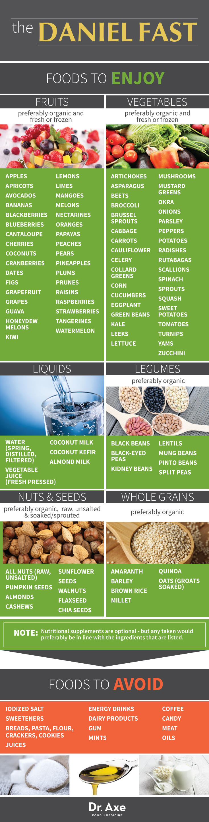

Fasting Benefits
There are numerous benefits to Daniel-type fasting, but it all starts with an inward, spiritual motivation.
“This is the fast that I have chosen…to loose the bonds of wickedness, to undo the heavy burdens, to let the oppressed go free, and that you break every yoke. Then your light shall break forth like the morning, Your healing shall spring forth.”
- Isaiah 58:6
Look at these incredible benefits of Fasting!


1. Spiritual Benefits of Fasting
- Fasting brings you closer to God
- Fasting makes you more sensitive to God’s voice
- Fasting helps break addictions
- Fasting shows us our weakness and allows us to rely on God’s strength



2. Mental & Emotional Benefits of Fasting
- Fasting relieves anxiety and nervousness
- Fasting can increase peace and shalom
- Fasting clears your mind of negative thoughts & feelings
- Fasting decreases brain fog
- Fasting helps increase your ability to trust God
- Fasting clears out toxins that can make you feel sluggish or depressed



3. Physical Benefits of Fasting
- Fasting helps break addictions to sugar
- Fasting supports the body’s detoxification
- Fasting promotes healthy weight Loss
- Fasting promoted healthy energy Levels
- Fasting improves skin health
- Fasting promotes healthy digestion and elimination
- Fasting supports healthy inflammation response and promotes joint comfort
- Fasting promotes healthy hormonal balance

Fasting Benefits: Spiritual, Physical & Mental/Emotional
When you fast and pray—two words that go hand-in-hand in scripture—you pursue God in your life and open yourself up to experiencing a renewed dependence on God, but it isn’t easy.
It is a spiritual discipline that requires denying your physical and mental self because your stomach and your brain will most likely work overtime to remind you when and what they want to eat!
As I mentioned earlier, Daniel wasn’t the only one in the Bible who fasted. There were others, but you don’t have to be a “spiritual giant” like Daniel or put yourself through torturous fasts to draw closer to God.

However, fasts can help focus your spirit, heart and mind on God and not your own eating and drinking desires. In fact, before you begin your fast, you can make a list of prayer requests you are asking God to answer. Then, every time you experience hunger pangs or food or drink cravings, ask God to work in those prayer request areas.
Also, spend quiet time with God each day and read passages of scripture from the Bible. You don’t have to be legalistic about this. There are many quality devotionals out there, so just choose one or ask a friend you trust to recommend one.
After all, it’s about your relationship with God, not your performance for God.
I also suggest journaling during your fast so that you can write down what you believe God is directing you in. For whatever reasons, many people say that they “hear” God more clearly during a fast than other times.
Isaiah 58:6, 8 says “Is not this the kind of fasting I have chosen: to set the oppressed free and break every yoke? Then your light will break forth like the dawn, and your healing will quickly appear.”
The truth is that “healing” can take place spiritually, physically and mentally when you fast.
We’ve discussed some of the spiritual aspects, but there are also specific physical and mental benefits to fasting, which happens to be one of the oldest therapies in medicine.
In fact, Hippocrates, the Father of Medicine, believed that fasting enabled the body to heal itself. How?
During a fast, many systems of the body are given a break from the hard work of digesting foods that it normally has to manage. The extra energy the body gains gives the body a chance to restore itself, while the burning of stored calories gets rid of toxic substances stored in the body.
Here’s another example. The digestive tract is the body area most exposed to environmental threats, including bacteria, viruses, parasites and toxins. Plus, most of your immune system is in your digestive tract, so it needs to be in top shape. When food is broken down in the intestines, it travels through the blood to the liver, the largest organ of the body’s natural detoxification system. The liver breaks down and removes the toxic by-products produced by digestion, including
natural ones and the chemicals which are typically present in our food supply and often on our daily menus.
During a fast, the liver and immune system are essentially freed up to detoxify and heal other parts of the body.
Now let’s talk specifically about the elements of the Daniel Fast, including vegetables, fruits and water. The antioxidants and nutrients in vegetables and fruits help to add vibrancy to your health, including your immune system, fertility, skin and more.
A diet high in vegetables and fruits is known for halting bodily inflammation and oxidation—two primary processes that can lead to ill health.
No wonder Daniel and his friends looked better than the others!

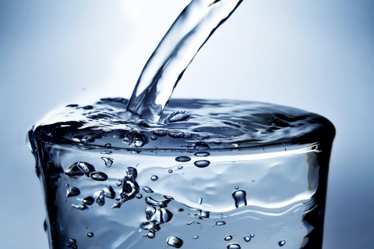

The Importance of WATER
Then there’s the water factor. The body is made up of approximately 60-70% water, and the body needs water to make new cells of all types, including blood cells, bone cells and skin cells. (1) Additionally, every organ and bodily system requires water to function correctly and healthily. Likewise, drinking enough water keeps your lymphatic system in tip-top shape so that wastes and toxins are removed from your body.
Water also keeps your joints lubricated, delivers nutrients to your nervous system, helps the blood transport oxygen and other essential nutrients to your cells, and even makes it so your heart doesn’t have to work as hard pumping blood through your body. Water regulates your metabolism, too, and aids in digestion and body temperature control. An added bonus is that adequate water intake hydrates your skin cells and plumps them up.
The brain, which is around 75% water, must be kept hydrated, too, and will redirect water from other areas of the body if it doesn’t get what it needs. (1) Getting enough water also keeps your metabolism motoring, can help you feel fuller and can keep your weight in check.
After a fast, including the Daniel Fast, people report a combination of spiritual, physical and mental benefits, including a closer relationship with God, answered prayers, a better state of health, freedom from food or beverage addictions, more energy, clearer thinking, a more positive attitude, feeling lighter and much more.



The Daniel Fast Story
Daniel was among the best and the brightest of the Israelites of his time. In the book of Daniel in the Bible, the backdrop is set: King Nebuchadnezzar of Babylon
had seized Jerusalem, the capital city of Judah, and had taken King Jehoiakam captive and overrun God’s temple.
As the victor, King Nebuchadnezzar had the power to select and “enlist” young Israelite men to serve in his Babylonian palace, and he wanted only the best. So, he chose young men from wealthy, influential families who are strong, handsome and intelligent, and who exhibited strong leadership qualities.
So, Daniel and some of his friends were “enlisted” in a three-year training time prior to entering the king’s service, and King Nebuchadnezzar appointed his chief official to be in charge of them and the other leaders-in-training.
Here’s the scenario: Daniel and his buddies—devout Israelites—are placed in a pagan palace to be trained up to serve a pagan king, a process complete with a prescribed diet of food and wine from the king’s own table. Most historians agree that the king’s menu most likely included food that had been sacrificed to idols and/or meat from unclean animals, both of which are strictly forbidden by Jewish dietary customs.
Daniel, being a winsome man of conviction, asks to eat only vegetables and to drink only water instead of what’s on the king’s menu. That request was acknowledged by (not approved by) the king’s chief official, but he didn’t want to risk Daniel and his friends looking unhealthy or frail by not eating what the other recruits ate. Since Daniel couldn’t get the king’s chief official to agree to the veggie and water diet, he asked the guard appointed to care for Daniel and his three friends instead.
It took some convincing, but Daniel’s request was granted. Here was the deal. Daniel said, “Please test your servants for ten days. Give us nothing but vegetables to eat and water to drink. Then compare our appearance with that of the young men who eat the royal food and treat your servants in accordance with what you see.” (Daniel 1: 12-13)
The guard agreed.
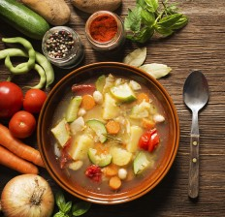
After ten days of only “pulse”—which consists of vegetables, fruits, seeds and grains—and water, Daniel and his comrades were brought before the King.
The results? Their health and appearance “appeared better than all the young men who consumed the ‘best’ food of the land from the very table of the king.”
Fast forward three years and beyond—while still eating only the pulse and water diet—and Daniel still outperformed those who ate the king’s delicacies. In fact,
the king found Daniel and his buddies were “ten times better than all the magicians and astrologers that were in all his realm.”
Ten times better!
What’s more is that Daniel outlived the king and advised the king’s grandson, Belshazzar, roughly 70 years after the reign of Nebuchadnezzar began!
That’s the story of Daniel’s 10-day fast that turned into three years as well as how it benefited him into his later years—which brings me to the 21-day Daniel Fast that is also mentioned in the Bible
The tenth chapter of Daniel describes how he ate “no choice food; no meat or wine touched [his] lips” (Dan. 10:3) for three weeks.
At this point in time, Daniel is approximately 85 years old, well beyond the years when he was a young man in King Nebuchadnezzar’s palace. However, Daniel was still attentive to what God had for him to do, which was also reflected in his diet.
For example, in Daniel 10, Daniel gets a vision from God about the future plight of the Jewish people for rejecting the Messiah and the gospel, leading Daniel into a state of sorrowful mourning that leads to his 21-day fast.
In Hebrew, the words “choice food” suggest that Daniel refused desirable foods, most likely breads and sweets or at least foods which were considered tasty. Once again, Daniel trimmed his diet down to the basics—only for sustenance, not indulgence or personal satisfaction—so that he could focus on the spiritual, not his personal needs or wants.
And while there certainly are spiritual benefits to fasting, physical and mental benefits can occur as well.
Are you ready to experience the incredible benefits of doing a Daniel Fast? If so then plan out your fast and try some of these healthy Daniel Fast recipes.

Daniel Fast Recipes
While most fruits and vegetables are edible as is, sometimes it’s nice to have recipes, so here are a few to get you started. Enjoy!

Granola
Ingredients:
- 1 cup crushed almonds
- 1 cup oats
- 1 cup sunflower seeds
- 1 cup pumpkin seeds
- 1/2 cup coconut flakes
- 1 cup honey
- 1 teaspoon cinnamon
Directions:
- Mix all together and spread out on a non-stick cookie sheet.
- Bake 20 minutes in a 250-degree preheated oven.
- Stir and continue to bake another 20 minutes, stirring periodically to prevent burning. The granola should be lightly browned.
- Remove from oven and serve warm or cool thoroughly and store in tightly sealed container or plastic bags.
- Option: After the granola is cooled, add raisins or other organic, unsulphured dehydrated fruit.

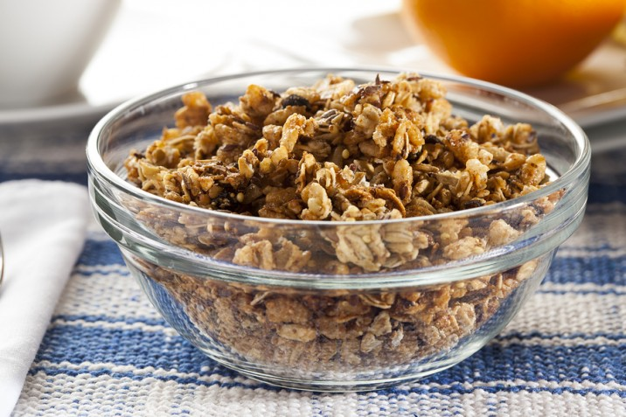

Minestrone Soup
Ingredients:
- 8 cups vegetable stock
- 1½ cups of dried garbanzo beans
- 2 cups dried red kidney beans
- ½ cup carrots
- 3 medium tomatoes (or one 14-ounce can of unsweetened, unsalted Italian tomatoes)
- ½ cup fresh parsley
- sea salt, to taste
- 1 cup cabbage
- ¼ teaspoon oregano
- ¾ teaspoon basil
- ¼ teaspoon thyme
- ½ cup celery
- ½ cup onion
- 1 clove garlic
- 1 package spinach noodles, cooked
Directions:
- Soak garbanzo and kidney beans overnight, drain and rinse.
- Peel and dice tomatoes.
- Cook and drain garbanzo and kidney beans as per directions on package.
- Mince garlic and parsley.
- Chop carrots, onion, celery, cabbage and garlic and sauté in water or soup stock over medium heat for 5 to 7 minutes.
- Stir in cooked and drained garbanzo beans, kidney beans, diced tomatoes and minced herbs.
- Bring to a simmer, then turn heat down and simmer 10 minutes.
- Stir in cabbage and parsley with lid partially on for about 15 minutes or until cabbage is tender.
- Add more soup stock or tomatoes as needed. Serve over cooked spinach noodles.
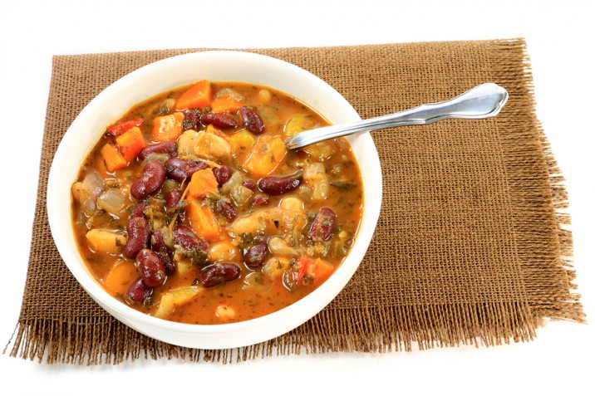

Black Bean Soup
Ingredients:
- 8 cups vegetable stock
- 1 cup celery
- 1 potato
- 2 garlic cloves
- 1 teaspoon honey
- 2 bay leaves
- sea salt, to taste
- 1 pound of black beans, soaked overnight, rinsed and drained
- 1 yellow or red pepper
- 1 cup carrots, diced
- 2 Tablespoons cilantro
- 1 Tablespoon parsley
- 2 Tablespoons marjoram
- 1 whole onion
Directions:
- Place beans in pot with vegetable stock, whole onion and bay leaves.
- Bring to a boil and cook 2½ hours or until beans are tender.
- Remove onion and bay leaves.
- Chop onion, pepper and celery.
- Grate carrots and potato on cheese grater.
- Mince garlic and sauté in a Tablespoon of olive oil until tender.
- During last hour of cooking, combine vegetables and seasonings with beans.
- Bring to a boil, lower heat to simmer and cook until veggies and beans are tender.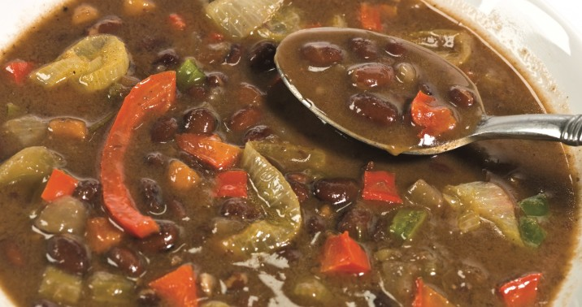

Stir Fry Vegetables
Ingredients:
- 1 red onion, sliced
- 3 stalks celery, thinly sliced
- ½ cup broccoli, chopped
- 1 bell pepper, sliced
- 1 teaspoon sea salt
- 3 carrots, peeled and sliced
- ½ cup cauliflower, chopped
- 1 cup zucchini, thinly sliced
- 1 cup yellow squash, thinly sliced
- 1 Tablespoon Oriental seasoning
Directions:
- Stir-fry all vegetables in 1 to 2 Tablespoons of olive oil until tender.
- Add salt and seasoning.
- Serve alone or over brown rice.

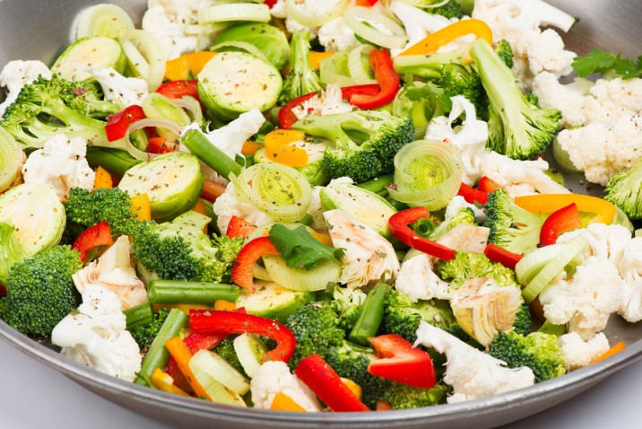

Harira
[Serves 4] (Note: Harira is a great recipe for the Daniel Fast as it has nearly 15 grams of protein per serving.)
Ingredients:
- 2 Tbl healthy oil, such as coconut oil or olive oil
- 1 cups chopped onion
- ½ cups chopped celery
- 2 cups warm water
- pinch of saffron threads
- ½ tsp salt, divided
- ¼ tsp peeled fresh ginger, minced
- ¼ tsp ground red pepper
- ¼ tsp ground cinnamon
- 2 garlic cloves, minced
- 2 cups organic mushroom broth
- 1½ cups chopped and seeded plum tomatoes
- ½ cup dried small red lentils
- 2 15-ounce cans no-salt-added chickpeas, drained
- 3 Tbl chopped fresh cilantro
- 3 Tbl chopped fresh parsley
Directions:
- Heat oil in a large saucepan on medium heat.
- Add onion and celery and sauté 4 minutes or until tender.
- Combine 2 cups warm water and saffron; let stand 2 minutes.
- Add ¼ teaspoon salt, ginger, red pepper, cinnamon and garlic.
- Cook 1 minute. Add saffron water mixture, broth, tomato, lentils and chickpeas.
- Bring to boil; then reduce heat.
- Simmer 20 minutes or until lentils are tender.
- Stir in cilantro, parsley and remaining ¼ teaspoon salt.
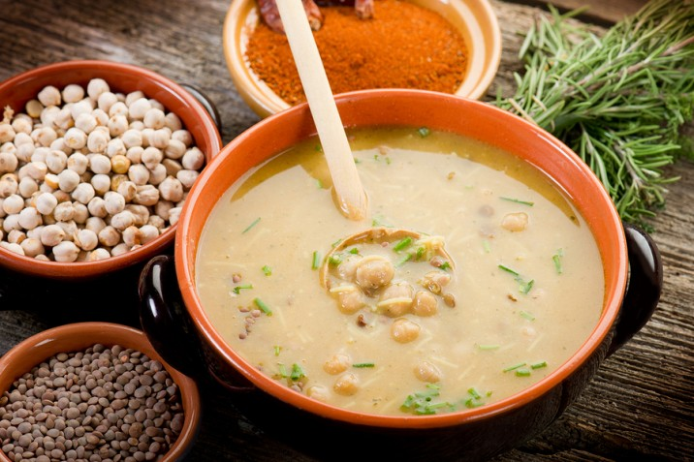

Daniel Fast Frequently Asked Questions (FAQ LIST):
First off, if you are pregnant or a nursing mother or are on a special diet of any sort for health reasons, then you should not go on the Daniel Fast without the approval of your primary healthcare professional.
Otherwise, here are some frequently asked questions you may want to know about.
1. What about prepared foods?
Read the labels of all prepared foods. Remember the Daniel Fast is sugar free and chemical
free. That is why I suggest organic, fresh or frozen foods.
2. What about pasta?
Make sure the label says whole grain or vegetable-based pasta like quinoa, black bean or brown rice with no additives or sugar. But, the diet should consist mostly of vegetables and fruits.
3. What about roasted nuts?
Try to stick to organic, raw, unsalted nuts and/or soaked or sprouted ones. These are harder to find, so if you have to choose roasted nuts, then get plain roasted, unsalted nuts with no preservatives.
4. How do I get enough protein in my diet while on the fast?
Protein-rich foods allowed on the Daniel Fast are almonds, sunflower seeds, lentils, quinoa, brown rice, split peas and some whole grains. Be sure you eat plenty of those.
5. What about salad dressing?
Salads are great on the Daniel Fast. Use olive oil and lemon or lime as salad dressing options.
6. Do I need to eat organic foods while on the fast?
You don’t have to eat organic, but I recommend it because choosing them keeps toxins out of your foods, meaning no use of chemically formulated fertilizers, growth stimulants, antibiotics or pesticides.
7. Can I go out to eat?
Yes; you can. Just make sure what you get is compliant with the Daniel Fast, such as a salad with olive oil and a baked potato with no extras on it.
8. What about bread?
If you eat bread, then I would only recommend a sprouted or sourdough bread that comes from ancient grains.
9. How much can I eat?
As long as your food choices fit the Daniel Fast, then you can eat all and as often as you want until you are satisfied!
If you want to learn more about biblical health, then check out this article on healing foods of the Bible.
- 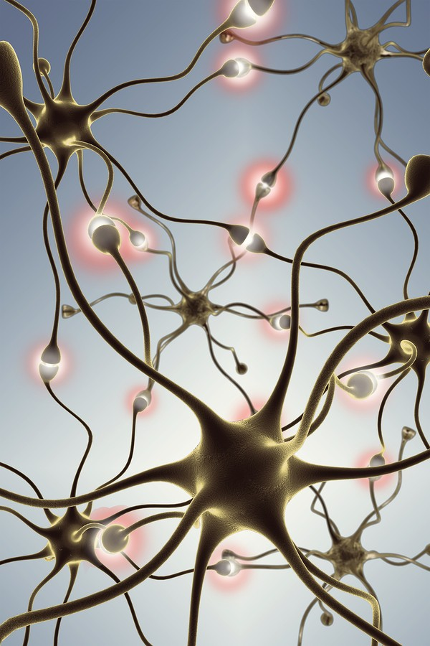
676615992413367&amp;ev=PixelInitialized">

