Cancer Fighting Foods – 4 Anti-Cancer Foods
Articles Featured Health — 14 May 2012

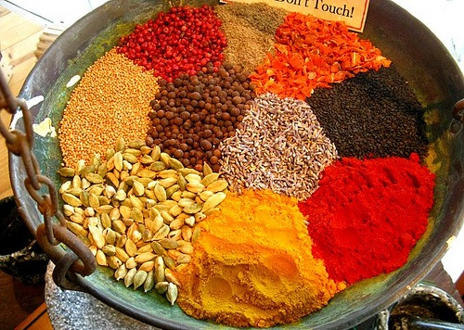
by Mike Barrett
Could it be that cancer rates are so rampant because people are simply not eating the right foods. While there are many factors that play into the development of cancer, diet and smoking habits make up nearly 60 percent of cancer cases. The food news is that with dietary and lifestyle changes, cancer rates can drop dramatically. One of the easiest ways to protect yourself against cancer is to consume many cancer fighting foods – here are 4 of them you should never forget about.

Cancer Fighting Foods – Turmeric (Curcumin)
Among the most currently researched of cancer fighting foods, turmeric has repeatedly been shown to be an effective cancer-fighter and even block cancer growth. Previously found to reduce tumors by an astounding 81%, the naturally occurring compound found in turmeric, curcumin, exhibits numerous anticancer properties. Researchers at UCLA found that curcumin is the component harnessing the ability to actually block cancer growth. Not surprisingly, the cancer-fighting ability that turmeric make up only a single facet of the many benefits of turmeric.

Papaya Leaf Extract
A study conducted by University of Florida researchers Dr. Nam Dang and colleagues in Japan has documented papaya’s powerful anticancer properties and impact against numerous lab-grown tumors – and without the negative consequences of chemotherapy. The researchers used papaya leaf extract for the study conduction, with the anticancer effects being even stronger with a larger dose of the extract. What’s more, the extract can be taken for a long time without side effects.
Another study also shows how papaya leaf extract is able to fight various cancers including cervix, breast, liver, lung, and pacreatic while aiding the cardiovascular and gastrointestinal systems.

Ginger
Adding another to the list of cancer fighting foods, ginger, a cousin spice of super anti-cancer substance turmeric, is known for its ability to shrink tumors. The subject of one study based out of Georgia State University, whole ginger extract was revealed to shrink prostate tumor size by 56% in mice. The anti-cancer properties were observed in addition to ginger’s role in reducing inflammation as well as being a rich source of life-enhancing antioxidants. You definitely won’t want to disregard the health benefits of ginger.

Garlic
For centuries, the benefits of garlic have been experienced by many cultures for the treatment and prevention of disease; garlic’s status as one of the cancer fighting foods is perhaps one of the most notorious. Scientists believe that the anti-cancer properties may be due to the production of something known as hydrogen sulfide. Also known to protect the heart, researchers at Albert Einstein College of Medicine found that damage to the heart muscle as a result of heart attack is halted by directly injecting hydrogen sulfide into mice. Researchers believe that the production of hydrogen sulfide is responsible for garlic’s ability to prevent various cancers including, prostate, breast, and colon cancer.
Beating cancer with nutrition is possible, you simply must recognize which foods to consume.
Additional sources:
PubMed
Phys.org
AAFP
Sources:
Natural Society
Picture


http://www.kyleleon-customizedfatloss.com/?lpid=woman&tid=wlwallcwlp300b149

