Benefits Of Beets – Miracle Cure Against Many Diseases
Posted By HealthyFood On Sunday, March 30, 2014 11:01 PM. Under Healthy Food
- See more at: http://www.healthyfoodteam.com/benefits-of-beets-miracle-cure-against-many-diseases/#sthash.SFnEe66E.dpuf
At first glance beets look as unattractive root, but fans of this precious vegetable do not need any incentive to include it in their diet. However, if you are one of those who do not like this vegetable we offer a reminder why you should start using it in your daily diet.

Helps with anemia
The first tip that will give every doctor in case of diagnosis of iron deficiency in the blood is eating beets as often as possible.
Keep in mind that when you eat beets, either to eat fresh as a salad, cooked or as juice, you can add some freshly squeezed lemon juice; in order to bind the iron and the body can absorb it.

Contain lots of minerals
Beet is rich in minerals like magnesium, potassium, calcium, iron and sulfur. It also contain group of B vitamins, among which folic acid, and vitamin C, which makes beet an excellent choice for pregnant women.

Better absorption of calcium
Due to the presence of silica, beets helps for better absorption of calcium in the body, this helps to maintain the health of bones, skin, hair and nails.

Cleansing the body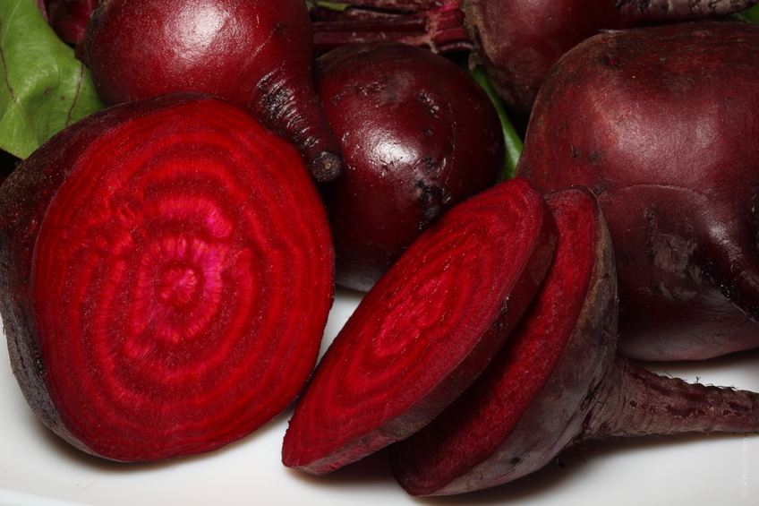
In raw or unprocessed form, beet contains betaine, which is excellent detoxifying ingredient regulates the secretion of bile and helps the busiest organ – the liver.
From a total of 500 functions that has bile, the most important are those relating to the removal of toxins and excess secretion of hormones and fat, and in addition to that, beetroot is its major ally.

Red against diseases and tumors
The pigment anthocyanins , of which beet gets red color , acts against various diseases , reduces tumor cells , and the attacked tissue gets normal structure.

Restores blood
Beet contributes to recovery of blood and it is a natural aid in the treatment of leukemia.

Lowers blood pressure
If consumed regularly, beets and beet juice can lower blood pressure

