8 Most Delicious Things You Can Do To Potatoes


Potatoes are actually a lot healthier than most people think. One of the reasons potatoes have a bad reputation in the dietary world is because of the ways that they are often cooked (fried), but there are lots of delicious ways to cook potatoes to get all of their health benefits.
Potatoes are readily available, inexpensive, and come in many varieties, but did you know that they are super nutritious? They contain vitamin B6 and, are a good source of potassium, copper, vitamin C, manganese, phosphorus, niacin, dietary fiber, and pantothenic acid.Potatoes also contain a variety of phytonutrients that have antioxidant activity. Among these important compounds are carotenoids, flavonoids, and caffeic acid, as well as unique tuber storage proteins, such as patatin, which can help against free radicals.
UK scientists at the Institute for Food Research have identified blood pressure-lowering compounds called kukoamines in potatoes, which were previously only found in Lycium chinense, an exotic herbal plant whose bark is used to make a medicine in Chinese herbal treatments. “Potatoes have been cultivated for thousands of years, and we thought traditional crops were pretty well understood,” said IFR food scientist Dr Fred Mellon, “but this surprise finding shows that even the most familiar of foods might conceal a hoard of health-promoting chemicals.”
Here are a few ways to prepare potatoes that are healthy, delicious, and easy.
1.Crash Hot Potatoes

2. Garlicky Smashed Potatoes

3. Eggy Potato Salad with Pickles

4. German Potato Salad with Dill
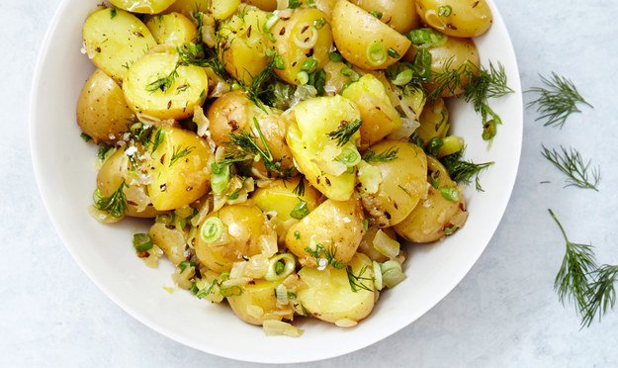
5. Creamy Roasted Garlic Potato Soup with Crispy Brussels + Chili Oil
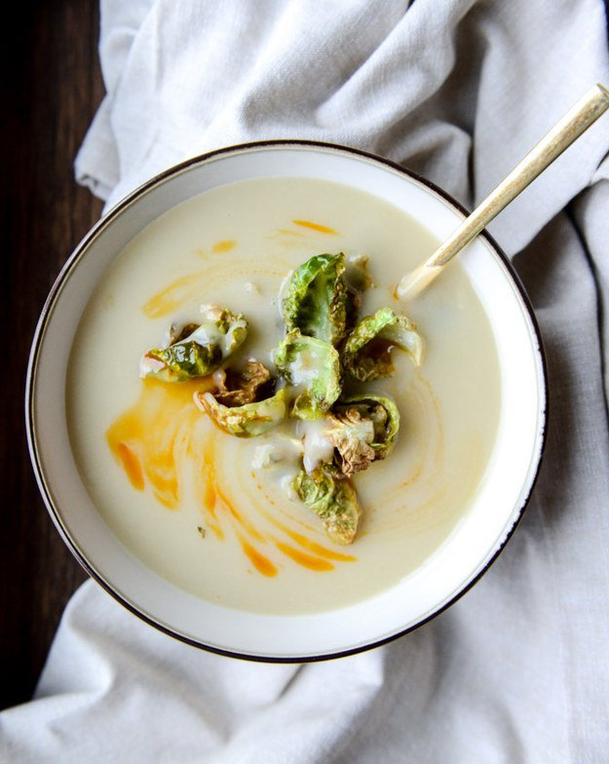
6. Baked Garlic Matchstick Fries

7. Garlic Ranch Roasted Potatoes
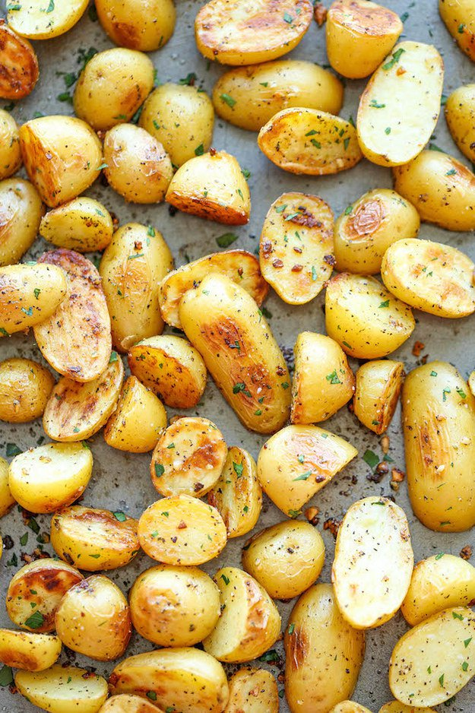
8. If All Else Fails…Just bake It

Sources:
Buzzfeed
World’s Healthiest Foods

