77 Coconut Oil Uses & Cures
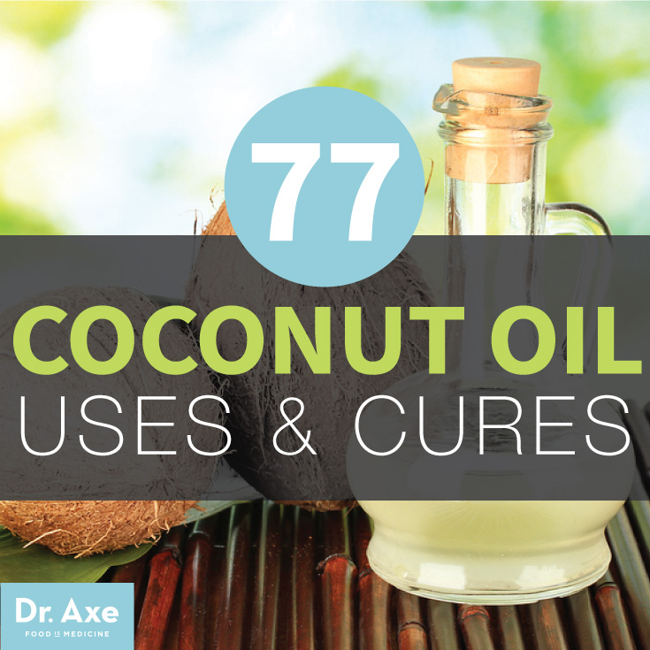

Coconut Oil
Coconut oil might just be the most versatile health food on the planet. Not only is it my favorite cooking oil, but coconut oil uses are numerous and can extend to being a form of natural medicine, be used for natural beauty treatments and so much more.
The coconut tree is considered the “tree of life” in much of Southeast Asia, India, the Philippines, and other tropical locations. And today, there are over 1,500 studies proving the health benefits of coconut oil.
Some of the top coconut oil benefits include:
- Balances Hormones
- Kills Candida
- Improves Digestion
- Moisturizes Skin
- Reduces Cellulite
- Decreases Wrinkles and Age Spots
- Balances Blood Sugar and Improve Energy
- Improves Alzheimer’s
- Increases HDL and Lower LDL Cholesterol
- Burns Fat
If you’re ready to take your health to the next level, try these 77 coconut oil uses and cures!

77 Creative Coconut Oil Uses

These coconut oil uses are broken into 4 categories: Food Uses, Body and Skin Care, Household, and Natural Medicine.

Coconut Oil Food Uses
1. Cooking at High Heat (Sauteing and Frying) - Coconut oil is great for cooking at a high heat because of its high smoke point. Many other oils like olive oil can oxidize when heated but because coconut oil is made up of healthy saturated fats it remains stable under high temperatures.

2. “Buttering Your Toast” – For breakfast in the morning, try spreading coconut oil on your sprouted grain bread, instead of conventional butter. The slight coconut flavor, more pronounced in the unrefined coconut oils, lends a lovely aroma and taste to your toast.
3. Natural Energy Booster - The medium chain triglycerides in coconut oil, when partnered with chia seeds, will give you an energy boost when you need a mid-afternoon pickup, or after a strenuous workout. Chia seeds are known to boost performance, and endurance while the coconut oil aids in digestion and metabolizing of the chia seeds. Mix 1 tablespoon coconut oil with ½ tablespoon of chia seeds, and enjoy from the spoon, or spread on sprouted grain bread.
4. Creamer for Your Coffee – Adding a spoonful of coconut oil to your coffee can give you an extra boost of energy and replace dairy creamer. If you put your hot coffee in a blender, with the coconut oil and your favorite natural sweetener, and blend, you will be amazed at the rich creamy flavor, without adding any dairy. In the Far East, many athletes blend their morning coffee with coconut oil and grass-fed ghee to increase performance and energy.
5. Chocolate Coconut Fondue – Enjoy dipping fresh fruit into dark chocolate? Well, by using coconut oil, dark chocolate has never been healthier, or easier. Slowly melt 1 tablespoon of coconut oil and 2 cups of chopped dark chocolate (preferably 70% cacao) together over low heat in a double boiler, stirring occasionally. If mixture is too tight, add a touch more coconut oil and stir until warm and melted. Transfer to a fondue pot, and dip with even more health-promoting foods like fresh strawberries, bananas, and sliced apples.
6. Boost Nutrients in Smoothies - Add 1 to 2 tablespoons of coconut oil to any fruit smoothie for a boost of cholesterol fighting compounds. Side benefit? It improves the texture and mouth feel of smoothies, while adding healthy fats to your diet.
7. Healthy Popcorn topping – Remember when you were a kid and visited your favorite theatre for a matinee? Remember the glorious smell that permeated the air? Chances are that it was popped in coconut oil. Pop organic corn kernels in coconut oil and then drizzle with just a touch more melted coconut oil and some sea salt.
8. Replacement for Non-stick Cooking Spray – In a non-stick skillet, sometimes eggs still stick. With coconut oil, that is no longer a problem. Add just a teaspoon or two of coconut oil to the pan, and melt. Add the eggs and cook as desired. Cleanup will be a breeze.
9. Create Healthy Homemade Mayonnaise – Use as oil in homemade mayonnaise recipe mixed with egg yolks. In a blender, combine 4 egg yolks, 1 tablespoon apple cider vinegar, and ½ teaspoon dried mustard. Blend until combined. With blender still running, slowly add 1 cup coconut oil (melted), and ½ cup olive oil to create an emulsion. If you add the oils too fast, the mayo will break. If this happens, all is not lost; add ½ tablespoon of tahini, and blend until smooth.
10. Topping For Baked Potatoes – Put coconut oil on baked sweet potatoes in place of conventional butter and then sprinkle on cinnamon. Also, use it for baked sweet potato french fries with some rosemary and sea salt.
11. Replace Unhealthy Fats When Baking - Yes, you can bake with coconut oil. Use the same amount as butter or vegetable oil that is called for in the recipe. For biscuits, piecrusts, and other preparations where the fat is to be cold, freeze the coconut oil prior to using. Use coconut oil to grease baking sheets and cake pans, and your baked goods will simply slide right out.
12. Make Homemade Healthy Granola- Homemade crunchy granola made using heart-healthy nuts is a great treat for breakfast, or as the star in a fresh fruit parfait in the evenings. Combine 3 cups of old-fashioned oats, 1 cup chopped almonds, 2 teaspoons cinnamon, ½ teaspoon salt, 1/3 cup honey or maple syrup, and 1/3 cup coconut palm sugar together in a large bowl. Melt 1/3 cup coconut oil and drizzle over, and then mix to combine. Bake on a cookie sheet at 350 degrees for 5-7 minutes, and then rotate in the oven, and continue baking for another 5-7 minutes. Turn off oven, and allow to sit for 30 minutes. Remove from oven, and break into clusters.
13. Sports Drink Replacement - Coconut oil gives the body quick energy in the form of its quick acting MCFA fats. Instead of relying on sugary processed drinks, try adding coconut oil and chia seeds to water with fresh fruit.
14. Natural Throat Lozenge - Use coconut oil in place of store-bought lozangers that are usually made using artificial flavors and colors. Try swallowing ½-1 teaspoon of coconut oil up to 3 times daily to ease the pain of a sore throat or cough, and combine licorice root tea with coconut oil for a natural throat soother. Try adding licorice root (fennel root), honey, and lemon too for an extra immunity boost again viruses and colds.
15. Prolong the Freshness of Eggs - You can use coconut oil to seal the pores in an egg shell and prolong the life of the eggs in your refrigerator. Try swiping a small amount of oil over the shells of the eggs and leaving it to penetrate, which will help prevent exposure to oxygen. This method should extend the life of your eggs for 1-2 weeks.
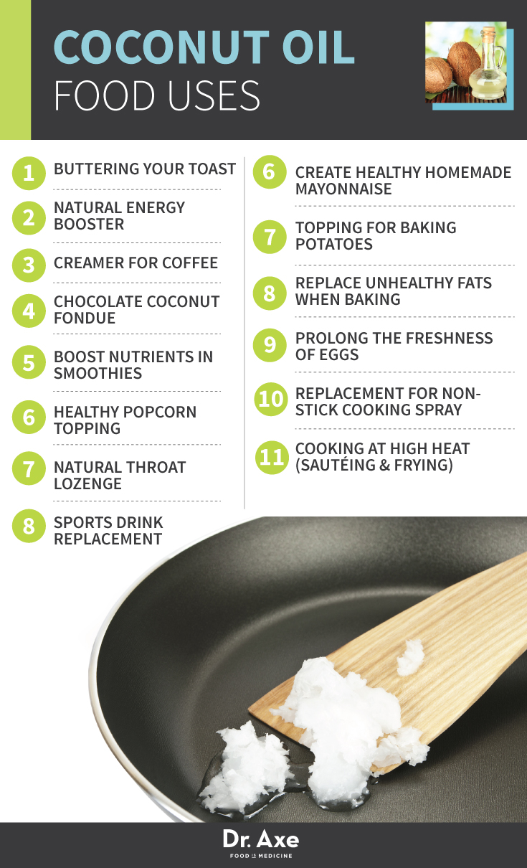

Coconut Oil Beauty & Skin Uses
16. Natural Skin Moisturizer - Using Coconut oil for skin health works well as a moisturizer for your face. It absorbs quickly, and is non-greasy. At room temperature, coconut is a solid, but it quickly melts when it comes into contact with hands. Before bed, wash your face, and pat dry. Warm a dollop the size of a pea in your hands and rub in a circular motion into your face. Let sit for 5 minutes, and then wipe off what is still on the surface.
17. Wrinkle Reducer - For areas of concern around eyes, dab just a touch around the eyes to help fight pre-maturing aging. Leave the oil on overnight to soak in, and wake up looking refreshed. Combine with frankincense oil for additional anti-aging benefits.
18. Natural Makeup Remover – Just a small dab of coconut oil will quickly liquefy eye makeup, making it easy to wipe off. Rub coconut oil gently onto the upper lids and lower lids in a circular motion. Wipe off with a warm cloth. The benefit over commercial eye makeup removers, is that coconut oil will not sting or irritate eyes, and as a bonus, will help to hydrate around the eyes.
19. Lock in Moisture After Showers - After your shower, apply coconut oil liberally all over your body. Coconut oil will hydrate dry skin, and helps to soothe skin after shaving. As a bonus, coconut oil has a natural SPF and is great to protect your skin from sun damage. If you are applying to the bottom of your feet, do so outside of the tub, so as not to slip.
20. Healing Bath with Epsom Salt – Regardless of the season, our skin takes a beating. Add ¼ cup Epsom salts and ¼ cup coconut oil to a warm bath, and relax. Add a drop or two of your favorite essential oils to add aromatherapy benefits. The Epsom salts will help to draw out toxins while the coconut oil will help to soothe dry skin.
21. Homemade Toothpaste - Mix equal parts of coconut oil with baking soda then add a few drops of peppermint essential oil for homemade toothpaste. Try my recipe for homemade probiotic toothpaste with coconut oil, Bentonite Clay, probiotics and peppermint essential oil.
22. Lip Balm – Dry chapped lips can happen during any season. Commercial lip balms are packed with unhealthy (and potentially toxic) ingredients, which is particularly concerning since we put them on our lips. The healing properties of coconut oil helps to nourish the lips, provides a touch of sun protection, and most importantly, is safe to consume. Combine 2 tablespoons of coconut oil with 2 tablespoons of beeswax, and 1 tablespoon of shea butter in a nonstick saucepan. Warm slowly until melted. Use a small funnel to refill used lip balm containers. Allow to set up for 6 hours.
23. Naturally Tinted Lip Gloss or Lipstick - You can naturally tint the lip balm recipe above with beetroot powder, cocoa powder, turmeric, and cinnamon. You only need a small amount of spices and a little bit goes a long way.
24. Personal Lubricant - Coconut oil is an effective and safe personal lubricant. Unlike commercial preparations, its anti fungal, antibacterial, and antimicrobial properties help keep the vaginal flora healthy. (One note: avoid using coconut oil or any oil with any latex contraseptives, as it can corrode the latex.)
25. Natural Mouthwash - Mix equal parts of coconut oil and baking soda, and then add a few drops of peppermint essential oils. Use daily to help whiten teeth, improve gum health, and freshen your breath. According to researchers at the Athlone Institute of Technology, the antibiotic properties of coconut oil destroy the bacteria that causes tooth decay.
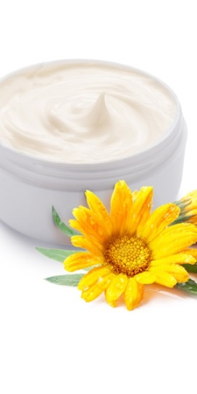
26. Coconut Oil Pulling – To improve the health of your teeth and gums, oil pulling with coconut oil, is the way to go. In Ayurvedic medicine practice, oil pulling is used to detoxify the mouth, killing bad breath, fighting bacteria, cures tooth decay, and helps to boost the immune system. Swish 1 tablespoon of coconut oil immediately after rising in the morning. Spend 10-20 minutes swishing; do not swallow the oil. Spit the oil into the trashcan (not into the sink!) and rinse with sea salt water.
27. Natural Deodorant – Coconut oil’s natural antibacterial properties help to keep body odor at bay. It is an excellent deodorant on its own, or when combined into a paste with baking soda and essential oils.
28. As a Gentle Face Wash – Coconut oil can be used in natural face wash recipe to cleanse an moisturize. Mix with lavender oil, tea tree oil and raw honey for best results.
29. Wound Salve – Coconut oil has been used for thousands of years to speed healing of rashes, burns, and open wounds. You can use it just like you would neosporin. To make a homemade neosporin mix coconut oil, frankincense, lavender and melaleuca oil. The antibacterial and antifungal properties of coconut oil help to keep the area free of infection, and the lauric acid in coconut oil helps to speed healing.
30. Cellulite Solution – To fight stubborn and unsightly cellulite, mix 1 tablespoon of coconut oil with 10 drops of grapefruit essential oil and massage in a firm circular motion into affected areas. Follow with dry brushing to help stimulate circulation and encourage cellular detox and my cellulite slim down juice recipe for best results.
31. Soothing Shaving Cream – If razor burn, ingrown hairs, or other skin irritation is a problem after shaving, start using pure coconut oil as your shaving “cream”. Warm a dab in the palm of your hands and rub on your face, under arms, on the legs, or the bikini area and then shave. Rinse well, and pat dry.
32. Sunscreen / Sunburn Remedy – Coconut oil is an all natural sunscreen and sunburn remedy, all in one. In fact, it is SPF 4, just enough to protect against sun damage, and the best of the nonvolatile herbal oils. Reapply as necessary, throughout the day. If you get too much sun, gently rub coconut oil into affected areas and it will promote healing, and soothe the pain.
33. Massage Oil – Coconut oil is a soothing and conditioning massage oil. Add a couple of drops of lavender oil and peppermint oil to help heal sore muscles, and stimulate mindful relaxation.
34. Insect repellent – Mix a tablespoon of coconut oil with a couple of drops of peppermint, rosemary, and tea tree oil to repel flies, mosquitos, gnats, and bees. This is a safe alternative to DEET and can be applied safely on all areas of the body.
35. Anti-Fungal Cream – Due to its antibiotic capabilities, coconut oil can be used topically to treat athletes foot and skin fungus. Apply some to the affected area and either leave it on or wipe off with a paper towel after it has time to set in.
36. Cold Sore Treatment - If you experience cold sores in or around your mouth, trying dabbing them with coconut oil several times per day to reduce healing time and pain. Coconut oil contains lauric acid which if effective at entering the virus that lives within cold sores and shutting off their ability to reproduce. This means you experience relief faster and are less likely to have scars or discoloration left in the area of the sore too.
37. Nail Cuticle Oil - Apply coconut oil to your finger beds to reduce the risk of developing fungal infections and to make it easier to push back cuticles so your nails can naturally grow more quickly. If you go to manicure salons to get your nails done, you may be at risk for coming into contact with serious viruses and bacteria that often live on salon equipment, so coconut oil offers another layer or defense.
38. Soothing Foot Rub for Cracked Heels - Find relief for your dry, cracked heals naturally by rubbing them with coconut oil and allowing the oil to penetrate your skin. Try using 2 tablespoons of oil for both heels, and feel free to add other essential oils- like lavender oil- which can help to further reduce dryness and bacteria, plus give your feet a nice, relaxing scent.
39. In-grown Hair Treatment and Preventer - Rub areas where you frequently shave or are prone to bumps and infection with coconut oil. The oil helps to soften skin so hair can easily grow through the follicle properly without becoming ingrown, plus it kills bacteria at the same time.
40. Sulfate-Free Shampoo – Coconut can cleanse hair if used with apple cider vinegar, and because it doesn’t have any harsh chemicals in it. This method leaves your color intact for longer, prevents dullness and orange or yellow discoloration, and makes your hair soft and shiny.
41. Natural Hair Conditioner - Using Coconut oil for hair conditioning has been used for thousands of years to strengthen and style hair. As a moisturizer, coconut oil can help strengthen hair while helping hair to retain moisture. Depending on the length and texture of your hair, you may need anywhere from 1 teaspoon to 2 tablespoons of coconut oil as a conditioner. Warm in the palms of your hands, and starting at the ends, work the oil into the hair.
42. Prevent and Treat Dandruff - This can help to encourage new hair growth, and will discourage dandruff. Rinse well (and then rinse again), and then style as usual. Your hair should be healthy, shiny, and full of body. If the coconut oil weighs your hair down, use less the next time, and rinse well.
43. Hair De-tangler for Children - Use a small amount of coconut oil on your children’s’ hair when it’s extra nutty and needs a natural, smooth solution for getting it brushed easily. Rub oil between your palms and then onto wet hair before combining through.
44. Homemade Exfoliator - Combine oil with organic coconut sugar or ground coffee beans to create a homemade facial or body scrub that will help remove dry skin. Do this twice weekly for smooth skin that is less likely to develop ingrown hairs, acne, blackheads, or other unwanted dullness.
45. Cheek Bone Highlighter – Try using coconut in place of makeup to add shine to your cheek bones and eye lids. This gives you a natural youthful glow and requires no make up, make up removal, or extra expensive products to purchase.
46. Makeup Brush Cleaner - Make up brushes are notorious for carrying loads of built-up harmful bacteria. Rub coconut oil on your make up brushes and leave them for 1-2 hours in order to disinfect them. Then wash thoroughly, although there is no need to worry about any oil remaining on your brush since it won’t harm your makeup for skin.
47. Hairbrush Cleaner - Use coconut oil in the same way as on your makeup brushes to remove unwanted hair and bacteria from your hair brushes. The oil even works well on delicate bore bristle brushes and helps the hair to easily slide on. Any oil that remains on your brush will only condition the brush bristles and your hair more afterwards.
48. Baby Ointment and Diaper Rash Guard - When your baby experiences painful diaper rash, rub some coconut oil around the affected area to sooth swelling, redness, itch, and burn. Try using 1 tablespoon to start and allow it to seep into the skin.
49. Hair Texturizer and Gel Replacement- Many commercial brands of hair gel and mouse contain alcohol which dries out your hair, not to mention many other toxic chemicals and fragrances. Try using a bit of coconut oil rubbed into the ends of your hair to hold its style and condition it at the same time. The oil prevents fly aways and adds extra shine too.
50. Natural Vapor Rub and Cold Remedy – Combine coconut oil with eucalyptus oil and rub the mixture on your chest or the chest of your children to open up your airways and facilitate breathing. Together these two work to increase circulation and clear congestion to help you get a good night sleep when you’re sick.
51. Stretch Mark Reducer – Try rubbing coconut oil all over the stomach during and after pregnancy to reduce unsightly stretch marks that occur when skin’s elasticity is compromised. The oil helps to fade dark marks, discoloration, and redness plus it hydrates the skin and allows it heal more quickly.
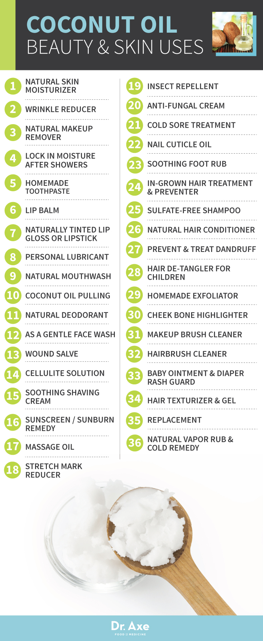

Coconut Oil Household Uses
52. Carrier Oil for Homemade Candles - Instead of buying expensive candles that contain artificial scents and chemicals, burn clean oil in your home using coconut oil and essential oils in an oil diffuser. These can be purchased online or at major home stores and give you endless ways to fill your home with healthy, inviting scents.
53. Help Unzip a Caught Zipper or Stuck Bike Chain - Apply coconut oil to chains or zippers that are jammed. The oil acts as a natural lubricant, allowing you to effectively break up a tough situation. Restore an old bike or a favorite pair of jeans by finally getting the chain or zipper to give!
54. Remove Gum From Hair or Furniture – If you’ve ever had gum stuck in your hair or on your coach, you know how frustrating this can be. Apply coconut oil to help the gum let up and easily get removed, without leaving any colors or stains.
55. Dust Preventer - Trying using a small amount of coconut oil on surfaces like wood, plastic, or cement that tend to gather dust. Rub a small amount of oil over the area and then allow it to dry, no need to wash it off or worry about it staining and attracting any bacteria.
56. Shoe Shiner - Instead of buying a leather repair kit or bringing used shoes to a repair shop, try subbing some coconut oil on your leather boots or patent heels to give them shine, disguise blemishes, and make them look fresh and new again.
57. Laundry Detergent - Combine coconut oil with lye, water, and essential oils of your choice to create a non-toxic soapy liquid that is perfect for cleaning clothes. The formula will not irritate your skin or have a negative affect on fabric, like many store-bought detergents can. This is a great solution for sensitive skin and those prone to allergies.
58. Furniture Polish - Use coconut oil on wood, granite counter tops, and metal surfaces to give your furniture and updates and clean, shiny look. At the same time this will help reduce dusk, cover up scratches, and clean your furniture and home surfaces too.
59. Rust Reducer - Rub some oil on your silver wear, outdoor metal furniture, car parts, or anything else that is metal and prone to rusting. Coconut oil helps to combat rust when you spread a thin layer of pure oil over the metal and let it sit for 1-2 hours. You can either wipe the oil off or wash it afterwards and should notice a difference right away.
60. Homemade Hand Soap - Use coconut oil to make homemade hand soap, and enjoy the flexibility to add any fragrance you want using essential oil. Try combining coconut oil with the substance Lye, or lard, which you can purchase online. The lye gives the soap natural texture and holds it together.
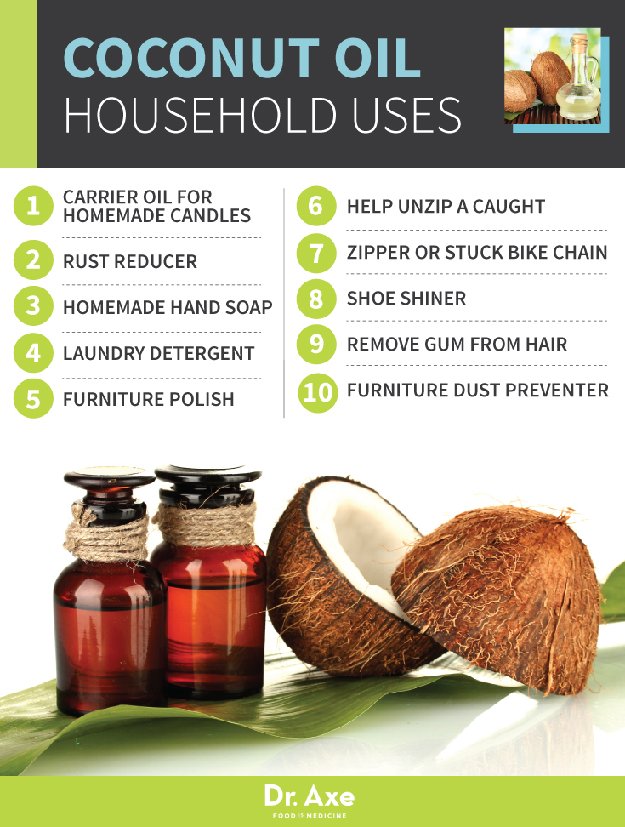

Coconut Oil Medicinal Uses
61. Fight Inflammation - Coconut oil supports both a healthy liver, and kidneys. According to researchers, virgin coconut oil, prepared without chemical or high-heat treatment exhibits an inhibitory effect on chronic inflammation. As inflammation is one of the leading causes of many chronic diseases, this study supports regular consumption of virgin coconut oil to help fight inflammation.


62. Boost Immunity - Coconut oil’s unique nutrition profile that is rich with lauric acid, capric acid and caprylic acid provides for strong antiviral, antifungal, antimicrobial, and antibacterial properties that have an immune boosting effect. By fighting these elements present in the body, the immune system is better equipped to respond properly when attacked.
63. Prevent Bone Loss and Osteoporosis Risk - Free radicals and oxidative stress are linked to the development of osteoporosis, a metabolic disorder. According to a recent study, virgin coconut oil is effective in maintaining bone structure, and preventing bone loss in estrogen-deficient rats. The report specified virgin coconut oil due to its high polyphenols and exerts antioxidant properties and you should take 3 tbsp daily for best results.
64. Alzheimer’s Treatment and Brain Health Protector - There are several reports that coconut oil may be an effective natural treatment for alzheimer’s disease. A current double blind study recommends taking 1 tbsp 3x daily.
65. Sleep Aid - Coconut oil is a perfect carrier oil when making soothing and relaxing home remedies using essential oils, like lavender or roman chamomile oil, that can help reduce anxiety and aid in getting a good night sleep.
66. Acne Fighter - Acne is a serious issue for adults in addition to teens and is commonly caused by bacteria overgrowth or an imbalance in oil on the skin. Coconut oil acts as a natural antibiotic, killing harmful bacteria that leads to serious breakouts. Try mixing the oil with tea tree oil and raw honey for added benefits and effectiveness..
67. Cancer Protection and Defense – Coconut oil and medium-chain triglycerides have been shown to provide a “potent antitumor effect and maintenance of a normal immune system” supporting the belief that coconut oil can help protect from certain types of cancers.
68. Candida Killer – Coconut oil contains caprylic acid which has anti-microbial properties that can kill yeast and candida. In a recent study, researchers found that coconut oil was active against species of Candida at 100% concentration, greater than the drug fluconazole. Add 1 tablespoon of coconut oil to your diet, and apply pure coconut oil directly to affected areas twice per day, until symptoms resolve. Follow my candida treatment protocol to help beat Candida.
69. Fat Burning Supplement - The MCT’s found in coconut oil have been proven to support weight loss and help your body burn fat for energy. Sounds odd right? Adding fat to your diet to burn fat? But the truth is not all fats are created equal. Add a tablespoon a day to reap the benefits of these fatty acids that may help to reduce abdominal fat. According to a study published in the American Journal of Clinical Nutrition, consumption of MCT oil leads to a greater rate of weight and fat mass loss than olive oil.
70. Hormone Balancer – The healthy fats in coconut oil support the thyroid and adrenal glands which can lower cortisol to naturally balance hormones. Coconut oils helps to suppress inflammation, while supporting healthy metabolism, two things that are essential for balanced hormones. The lauric acid, and other compounds support the thyroid and adrenal glands. This helps to lower cortisol, and naturally balance the hormones.
71. Digestive Support – Coconut oil is easy to digest and contains compounds that destroy bad bacteria, promote growth of probiotics and helps heal leaky gut. Coconut oil promotes the growth of healthy probiotics in the digestive tract. The antibacterial, antifungal, and antimicrobial properties help to control parasites, and fungi, while aiding in the efficient absorption of essential nutrients.
72. Blood Sugar Stabilizer and Diabetes Preventer – Coconut oil can help balance blood sugar levels and has been medically proven to improve diabetes. Coconut oil can help balance blood sugar levels by encouraging efficient secretion of insulin from the pancreas. In a 2009 study, researchers found that medium-chain fatty acids “may therefore be beneficial for preventing obesity and insulin resistance.”
73. Ezcema and Psoriasis Cure Treatment - Coconut oil can be used as cream to naturally heal dry and flaking skin for those with Eczema and Psoriasis. Mix coconut oil, shea butter and geranium oil for the best benefits.
74. Balance Cholesterol Levels – The healthy fats in coconut oil have been proven to increase HDL cholesterol and lower LDL cholesterol supporting heart health. According to a study reviewed by Harvard Medical School, coconut oil consumption increases HDL cholesterol, and improves the cholesterol ratio.
75. Constipation Relief - Many people swear by coconut to cure chronic constipation and relieve bloating. Try taking one tablespoon of coconut oil in the morning or before bed in order stay regular. The oil penetrates the digestive track and keeps things running smoothly by killing off harmful bacteria and allowing your gutflora to re-balance.
76. Fight Heart Disease- After decades of coconut oil being vilified due to its saturated fat content, new research is now proving that medium-chain fatty acids and coconut oil are beneficial to heart health and help lower high blood pressure.
77. Help Sick Pets - Just like their human caretakers, dogs and cats can benefit from the addition of coconut oil to their diet. Pets with digestive upset can benefit from a teaspoon or two of coconut oil mixed into their food. Skin allergies, irritations, and wounds can be soothed, and healing accelerated with a topical application. Unlike other salves, since it is edible coconut oil, there is no health risk if they lick it off their coats.
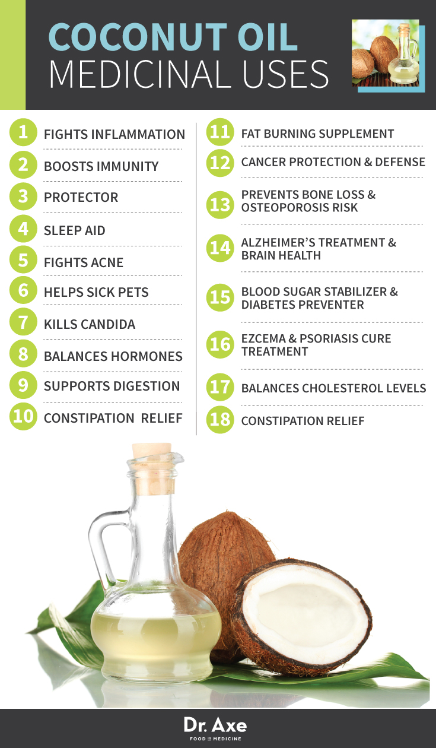

As you can see, coconut oil uses are numerous and so are the health benefits.

Coconut Oil Nutrition Profile
Coconut oil, like other plant-based oils, does not contain cholesterol. The vast majority (more than 85%) of the fats in coconut oil are medium-chain triglycerides. These medium chain fatty acids (MCFA’s) found in coconuts has tremendous health benefits; they are easy to for the body to burn as fuel for energy and have anti-microbial properties, in addition to other important traits.
Coconut oil contains three unique fatty acids that are responsible for its various health benefits:
- Lauric acid
- Capric acid
- Caprylic acid
These are some of the rarest substances found in nature and the reason why this oil is so beneficial.
Lauric acid has a particular structure that allows the body to absorb it easily. Once absorbed, it morphs into monolaurin, found in human breast milk, and coconut milk and oil. Monolaurin is known for its antiviral, anti-micorbial, and antibacterial properties.
In addition, coconut oil contains linoleic acid, oleic acid, phenolic acid, myristic acid, Vitamin E, Vitamin K, and iron.

Organic Extra Virgin Coconut Oil vs. Refined Coconut Oil
To reap the many benefits of coconut oil, it is essential to choose organic unrefined coconut oil, preferably produced from a “wet-milling” process. Organic, unrefined coconut oil is extracted from fresh coconut meat; not from dried coconut.
The oil is then separated from the water, through centrifuge, fermentation, boiling or refrigeration. Fermentation is the preferred method to ensure that the coconut oil retains its inherent health benefits.
Unlike olive oil, coconut oil is thermally stable, and the antioxidants are not lost through the heating process. Multiple scientific studies conducted in Sri Lanka, Malaysia, and other countries where coconuts are native have shown that the wet-milling fermentation method followed by “hot extracted virgin coconut oil” produces the highest level of antioxidants and lowers bad cholesterol, while raising good cholesterol.
While the heat process may seem counter-intuitive based on what we know about heating and the destruction of nutrients, coconut oil reacts differently to heat than other foods. For example, the case with harmful GMO oils is usually the opposite; they have been heated to the point of oxidizing and becoming toxic.
According to a study published in Food Science and Biotechnology, virgin coconut oil that is produced with heat, results in the highest number of antioxidants. Researchers believe that this may be due to the release of polyphenols from the bound structure.
Refined coconut oil has a higher smoke point and is void of the coconut flavor. These coconut oils are mass-produced, typically through a chemical distillation process that starts with desiccated coconut that is not fresh. The coconuts are further bleached and deodorized to make them “more palatable” to the American consumer.
Some of these refined coconut oils are even hydrogenated, which turns this healthy natural oil, into a synthetic trans-fat. For this reason, avoid refined coconut oils as much as you possibly can.

Where to Buy Coconut Oil
There are many brands of coconut oil on the market today, but the one I personally use and recommend to all my patients is tropical traditions coconut oil.

