5 Herbs & Spices That Belong In Every Home
31 December, 2014
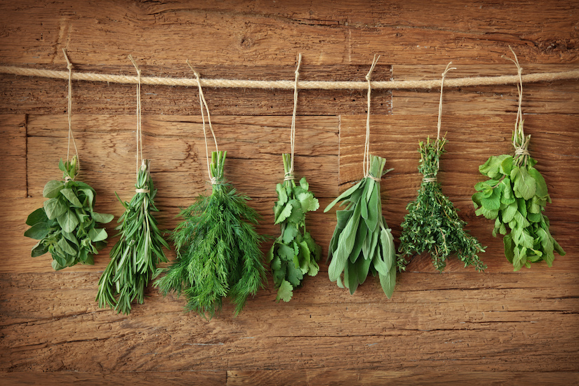
Talia Fuhrman (Mind Body Green )
We all think of fruits and vegetables as being great for promoting wellness, but most of us don’t immediately consider herbs and spices when we imagine the foods we should be consuming for ideal health. The reality is that herbs and spices are jam-packed with health-promoting chemicals, and they have more antioxidants than most fruits and vegetables. Here are five herbs and spices that are especially great for fending off disease.

Rosemary
The health benefits of rosemary are astonishing. Studies have implicated rosemary as an anti-cancer compound, memory enhancer, mood elevator, migraine killer, immune booster and improver of digestive health. The most striking finding may be rosemary’s ability to prevent breast cancer. Research indicates that crude ethanolic extracts of rosemary can prevent the proliferation of breast cancer cells in the laboratory. Furthermore, rosmarinic acid, extracted from the leaves of Rosmarinus officinalis, has the capability of inhibiting the expression of genes that increase the risk of development of tumors in multiple types of tissue, including breast tissue. Say hello to rosemary and goodbye to the expression of breast cancer genes.

Ginger
Think anti-inflammatory when you think of ginger. Ginger contains multiple anti-inflammatory compounds, including gingerols, which have been found to possess anti-cancer properties and reduce aches and pains associated with osteoarthritis and sore muscles. Clinical trials indicate that 75% of arthritis patients and 100% of patients with muscular aches felt relief of pain and swelling after onsuming ginger regularly. Another study found that mice fed ginger for five days prior to exposure to radiation prevented free-radical damage to lipids. The ginger also reduced depletion of the animals’ stores of glutathione, one of the most important antioxidants produced internally by the body. Anti-inflammatory compounds in ginger are immune system boosters, so add ginger to your green drinks and meals and rejoice that you're helping your body stay in tip-top shape.

Parsley
This light and refreshing herb is bursting with vitamin C, vitamin K, vitamin A and folate, all vital nutrients for disease prevention and maintenance of cardiovascular health. Parsley is also a cancer fighter. Studies indicate that myristicin, an organic compound found in parsley, not only has the ability to inhibit tumor formation that can lead to cancer, but also activates the enzyme glutathione-S-transferase, which assists in fighting oxidative damage. All oxidative damage fighters detoxify our cells and promote vitality.

Sage
Like rosemary, sage contains potent antioxidants that have been shown to avert mental decline as we age. Sage is a member of the mint family and is packed full of volatile oils, flavonoids and phenolic acids, all of which play a role in disease prevention. This nutrient-dense spice is also a source of anti-aging enzymes, such as superoxide dismutase (SOD) and peroxidase. These chemicals work in conjunction to provide unique health benefits that fight free-radical damage, which in turn keeps our cells functioning optimally and prevents premature cell death. Preliminary studies suggest that sage can alleviate early symptoms of Alzheimer’s disease by preventing the destruction of acetylcholine, a brain chemical responsible for memory and learning.

Thyme
Thyme was associated with courage in ancient Greece, which is a reason to like thyme regardless of its health benefits. Greek translation aside, thyme is a nutrient powerhouse. Thyme contains thymol, carvacolo, borneol, and geraniol, all volatile oils that protect and substantially increase the percentage of healthy fats found in cell membranes and other important cellular structures. In particular, the amount of DHA, an omega-3 fatty acid critical to optimal brain functioning, was increased after dietary supplementation with thyme. Thyme also contains a slew of flavonoids that act as antioxidants, which help slow down the ageing process. This is one spice that is sure to spice up your life and help you stay looking and feeling young!

What Are Your Go-To Spices & Herbs At Home?
Source: Mind Body Green

Related Articles
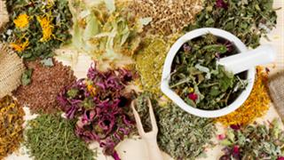

5 Herbs To Calm Anxiety (Without Being Drowsy)
30-Mar-2014
Anxiety is a condition that disrupts so many people's daily lives (approx. 18% of the US population). If you're tired of running on adrenalin and feeling like a ball of tension, try these 5 natural herbs; they are known to be effective for calming the body and most importantly they're drug-free. The solutions are here, we just need to find them!

SHARES 29.3k
59
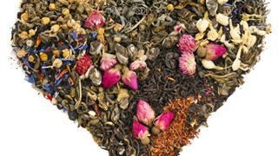

Top 4 Herbs To Fuel The Bedroom Fire (His & Hers)
06-Feb-2014
Do you suffer from a low sex drive and want to ignite your libido again? Try these 4 natural herbs that can awaken your inner sex kitten and have you purring with bliss.

SHARES 639
4
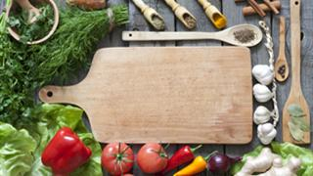

Top 8 Foods & Herbs For Preventing Cancer
30-Mar-2014
The number one prescription for cancer is PREVENTION! Preventing and calming cancer could be as easy as adding a sprinkle of turmeric to your cooking, ordering a wakame salad with your sushi or maybe you are feeling a little more ambitious and want to try some medicinal mushrooms? Discover the top 8 potent cancer calming foods and herbs.

SHARES 1.7k
3

Related Products
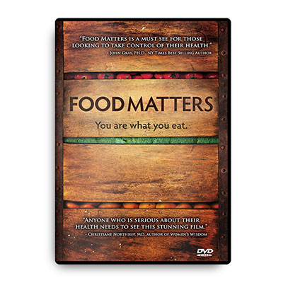

FOOD
MATTERS DVD
Food Matters is a feature-length documentary film informing you on the best choices you can make for you and your family's health. In a collection of interviews with leading Nutritionists, Naturopaths, Scientists, M.D.s and Medical Journalists, you will discover...
RETAIL: $24.99
$19.99
LEARN MORE
ADD TO CART


Hungry For
Change DVD
We all want more energy, an ideal body and beautiful younger looking skin... So what is stopping us from getting this? Introducing 'Hungry For Change', the latest 'Food Matters' film. 'Hungry For Change' exposes shocking secrets the diet, weight loss and food industry don't want you to know about. Deceptive strategies designed to keep you craving more and more. Could the foods we are eating actually be keeping us stuck in the diet trap?
RETAIL: $24.99
$19.99
LEARN MORE
ADD TO CART
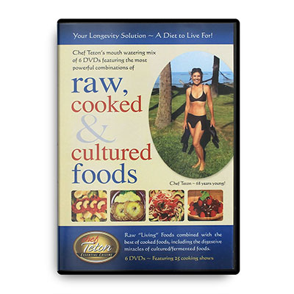

ESSENTIAL CUISINE
COOKING CLASSES DVD
Learn how to prepare more healthier and delicious meals with Chef Teton. This cooking class series on DVD is the best way to start preparing delicious and easy meals for the whole family to enjoy.
$59.99
LEARN MORE
ADD TO CART



Looking to kickstart your health?
GET STARTED WITH A FREE FOOD MATTERS GIFT PACK
CHOOSE YOUR GIFT >

8.4k LIKE
50 TWEET
526 PIN
7 COMMENT
0
8.9k SHARES



Get a weekly dose of wellness inspiration
- Healthy Lifestyle Tips
- Quick & Easy Recipes
- Natural Healing News & More!




We here at Food Matters are committed to helping you help yourself. We believe that your body is worthy of good care and that no one is more suitably qualified to care for it than yourself. Think of us as your nutritional consultants and know that we are here with you on your journey to a healthier life.

Read more about us.




