33 Surprising Baking Soda Uses & Remedies
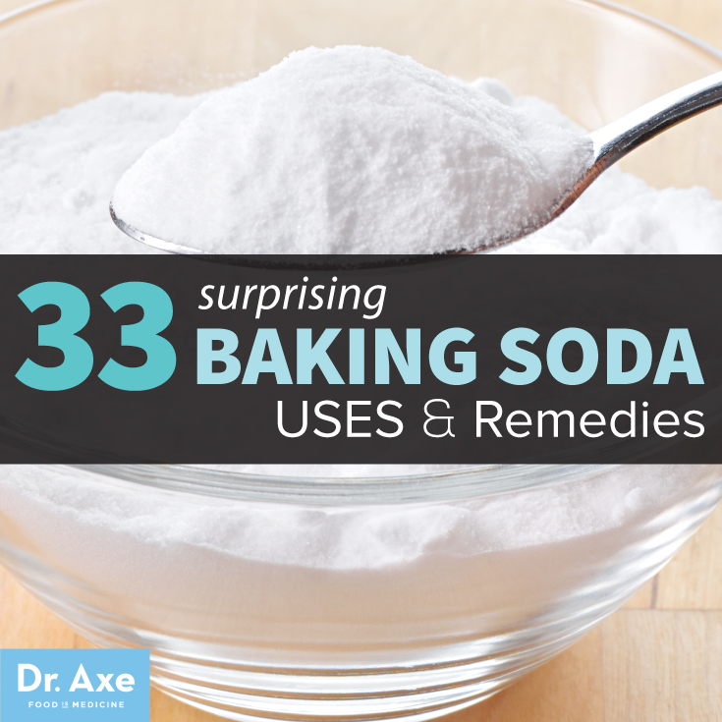

These Baking Soda Uses Will Surprise You!
Many of us think of baking soda as an ingredient used for cooking, or even something that helps to keep our refrigerators odor-free, but baking soda is surprisingly good for your health and home, too!
An inexpensive purchase (usually costing about $1), baking soda uses vary from basic daily hygiene, injuries, digestive issues, stomach pain, coughs and sore throats.
Throughout history, baking soda has been used as a rising agent when baking. It’s 100 percent sodium bicarbonate; so when mixed with acid, baking soda makes bubbles and gives off a carbon dioxide gas, causing the dough to rise.
Baking soda is known as nahcolite, which is part of the natural mineral natron. Natron contains large amounts of sodium bicarbonate and has been used since ancient times as a deodorizer, soother and cleanser.

Baking Soda Uses & Benefits
Baking soda is a great tool for cleaning and removing stains, but there are many health benefits associated with the use of baking soda, too. Some of the most common baking soda benefits include:
- Eases stomach pain
- Helps with digestive issues
- Relieves bloating and gas
- Fights off diseases
- Neutralizes acid
- Kills fungi, mold and parasites
- Minimizes cough and sore throat
- Reduces the duration of cold and flu
- Helps pH balance
- Reduces the symptoms of gout
- Promotes kidney health
- Treats urinary tract infections
- Reduces muscle pain and fatigue

Top 33 Baking Soda Uses

Baking Soda Uses: FACE & SKIN
1. Natural Deodorant – Create your own deodorant by mixing a teaspoon of baking soda with enough water to create a milky paste, then rub it under your underarms or even on your feet.
2. Face Exfoliator – Remove dry skin from your face by creating your own baking soda exfoliate. Combine one teaspoon of baking soda with half a cup of water and rub it on your face in a circular motion, then rinse.
3. Hand Softener – To scrub away dirt and odors, mix baking soda with warm water and rub it on your hands. This natural scrub will leave your hands clean and soft.
4. Feet Soother – Create your own foot bath with a tablespoon of baking soda and warm water. The baking soda will remove bacteria and odors, and it will help to prevent toenail fungus.
5. Itchy Skin Relief – Baking soda can help to reduce discomfort from sunburn, allergic rashes, and skin affected by poison ivy or poison oak. Mix a teaspoon with some water to create a paste – then rub it on your skin.
6. Splinter Removal – Splinters will come out naturally after a few days of soaking it in baking soda (use a mix that includes a tablespoon of baking soda and warm water). Soak the affected area twice a day.
7. Bug Bite Soother – Rub baking soda on your bug bite to relieve the itching. Create a paste with a teaspoon of baking soda and water. Keep applying the paste – about three times a day until the bite dissipates.
8. Sunburn Relief – Your fragile sunburned skin will benefit from soaking in a mixture of baking soda and water. Draw a warm bath and add half a cup of baking soda; you can also mix baking soda into your favorite body lotion.
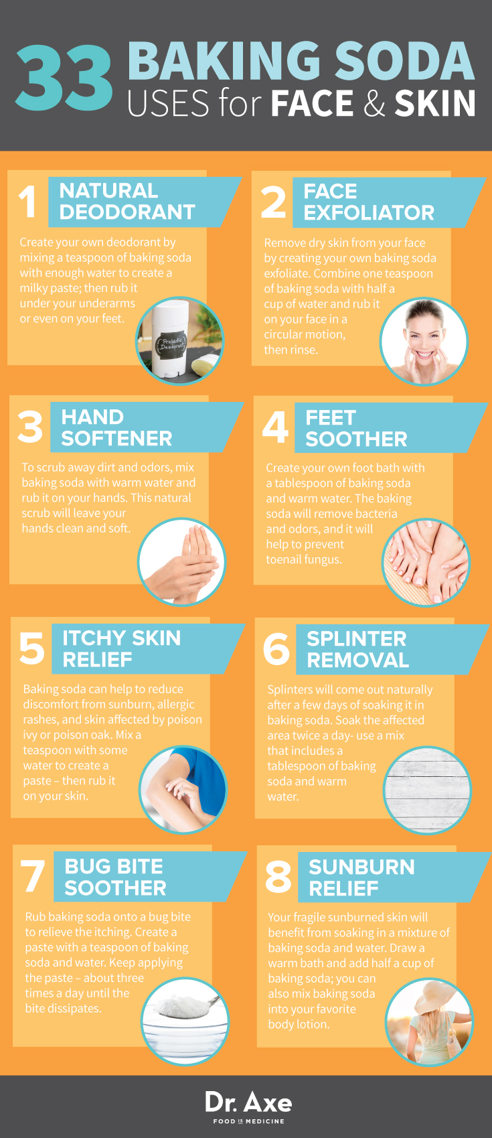

Baking Soda Uses: HAIR & TEETH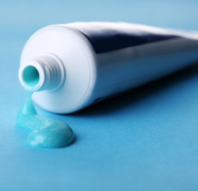
9. Hair Cleanser – Add a teaspoon of baking soda to your shampoo and rub it into your hair. This is a great way to remove dirt and oil, or residue that is left over from hair products.
10. Brush and Comb Cleaner – You don’t want to use harmful chemicals in your hair products, so use baking soda to clean your brushes or combs. Take advantage of this baking soda benefit by creating a natural paste by combining two teaspoons of baking soda with one cup of water. Rub the paste into your hair product and then rinse.
11. Homemade Toothpaste – Baking soda is known to increase plaque removal — that is why it’s commonly used in toothpaste. Straight baking soda has abrasive qualities, and over time it may wear away enamel. Instead, to keep fresh breath, you can add baking soda to your toothpaste or just dip your toothbrush in baking soda a few times a week. (1)
12. Teeth Whitener – To keep your teeth looking pearly white, create your own paste with a teaspoon of baking soda and water. Once a week, rub the paste onto your teeth, let it sit for five minutes, and then rinse your mouth. (2)
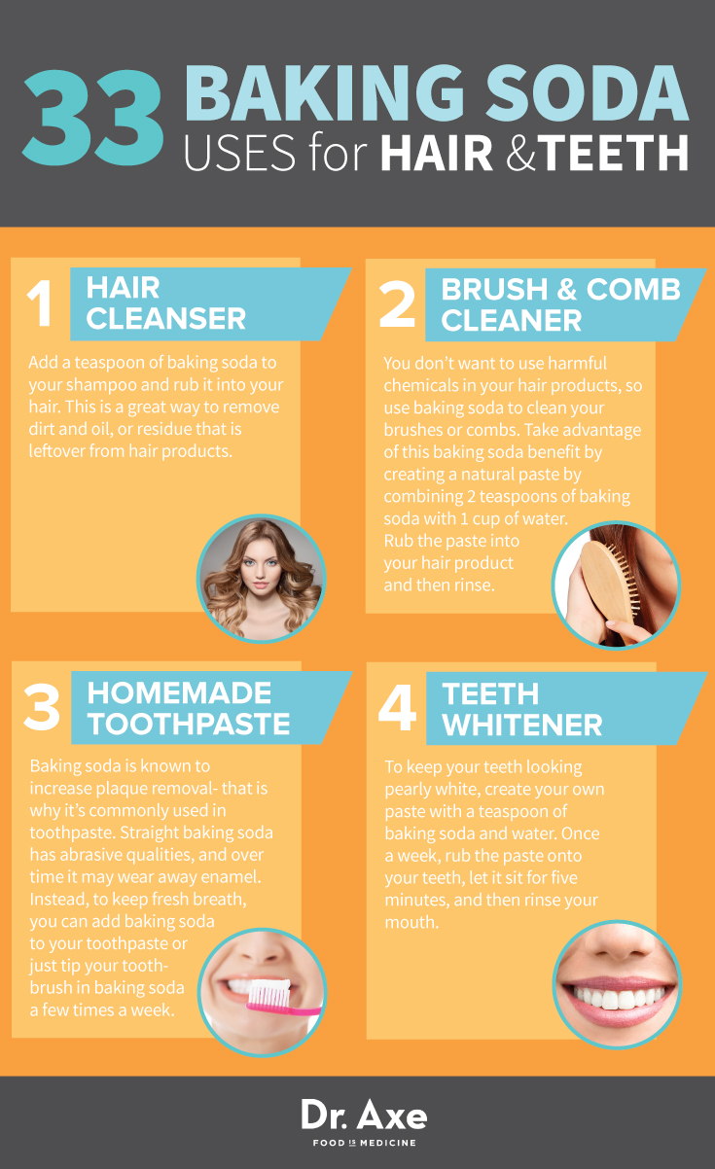

Baking Soda Uses: NATURAL HEALTH
13. Heartburn and Indigestion Relief – Baking soda is a cost-effective way to reduce heartburn and indigestion, as opposed to other options like Tums and Rolaids, which also contain bicarbonate. Simply add half a teaspoon of baking powder to two cups of water. An hour after eating, drink this mixture to gain some relief.
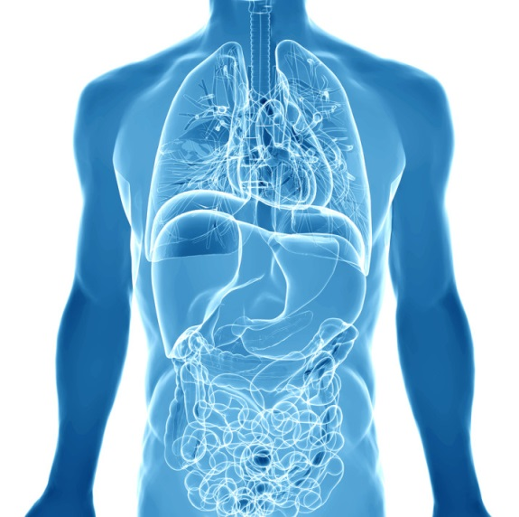
14. Cancer Prevention – Baking soda is known to increase the pH of acidic tumors without affecting the pH balance of healthy tissues and the blood. When you have a pH imbalance, unhealthy organisms are able to flourish, which damages tissues and organs, and compromises the immune system. Baking soda consumption can be used as a means of nutritional and immune support for people with cancer.
15. Exercise Enhancer – The baking soda benefits can change your exercise routine, too. It has the power to absorb the lactic acid that builds up in muscles during vigorous workouts, which can delay fatigue and enhance your athletic performance. You can consume baking soda by drinking a teaspoon with water.
16. Improve Kidney Function – As an alkaline substance, baking soda buffers acids in the body and helps to keep pH levels balanced. Low-functioning kidneys have a hard time removing acid from the body, so consuming baking soda will help with just that.
17. Reduce Ulcer Pain – Because baking soda neutralizes stomach acid, it’s the perfect remedy for ulcers. Drink a glass of water with 1-2 teaspoons of baking soda to relieve symptoms.
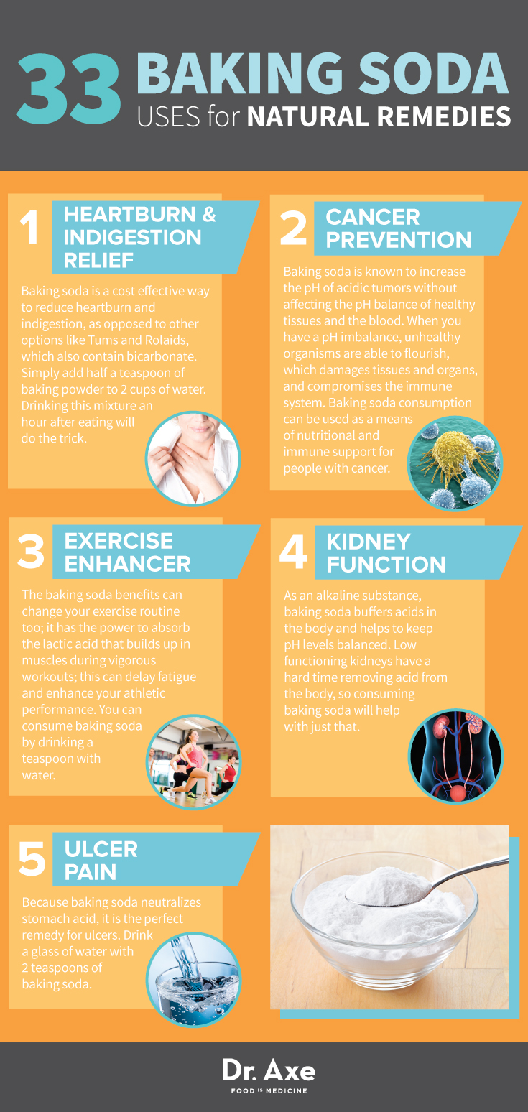

Baking Soda Uses: HOME
18. Natural Kitchen Scrub – Sprinkle baking soda on the surfaces in your kitchen and use a sponge or rag to scrub. You can even add lemon, lavender or peppermint essential oil to add a natural and healing fragrance to this DIY cleaning product.
19. Pots and Pans Cleaner – Baking soda can be used to hand wash pots and pans, and it won’t hurt these valuables either. Just let them soak in baking soda for 15-20 minutes … the grease, grim or food will come right off.
20. Carpet Cleaner – Many carpet cleaners include chemicals that can be harmful to your pets or children, so use baking soda to give your carpet a good cleaning instead. Sprinkle your carpet with baking soda; let it sit for 15-20 minutes, and then vacuum.
21. Gentle Baby Clothes Cleanser – Baking soda can be used as a 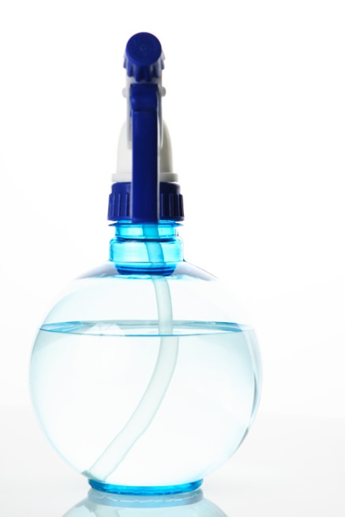natural cleanser and even a fabric softener. It’s the perfect way to clean baby clothes — just add one cup to your laundry load.
22. Fruit and Veggie Scrub – Make your own natural scrub by adding a teaspoon of baking soda to water. The pasty mixture is a perfect way to remove bacteria from your fruits and veggies.
23. Silverware Cleaner – Create a paste that is three parts baking soda and one part water. Rub the paste onto your silverware and let it sit in a large tray or bowl. After 15-20 minutes, rinse the silverware.
24. Microwave Cleaner – Don’t use harmful chemicals to clean your microwave; instead, just add a teaspoon of baking soda to a damp rag. This combination will wipe away food and grease easily.
25. Drain Cleaner – Mix baking soda with apple cider vinegar to create your own drain cleaner. This is a much safer option than the harmful chemicals that are typically used to clear drains. Let the combination bubble for 15 minutes, then rinse it with hot water.
26. Dish-Washer Helper – Add baking soda to your regular dish washing cycle; this will help to eliminate unwanted grease and grime that builds up on your dishes.
27. Fire Extinguisher – If you experience a minor grease fire in your kitchen, you can use baking soda to put it out. Pour baking soda on the fire and it will stifle the flames instantly.
28. Shoe Deodorizer – Can’t get that smell out of your shoes? Sprinkle baking soda inside your shoes and the smell will clear up within minutes.
29. Coffee and Tea Pot Cleaner – To remove coffee stains and funky tastes from your coffee or tea pot, make this quick mixture: one-fourth cup of baking soda with one quart of warm water. Rub the mixture on and in your pots; if you are battling tough stains, let it sit for a few hours first and then rinse.
30. Shower-Curtain Cleaner – Get rid of those stains that show up on shower curtains by rubbing baking soda onto them. Add a little water and the grime will be gone shortly.
31. Closet Freshener – To keep your closet smelling clean and fresh, place a box or cup of baking soda inside.
32. Wash Your Car – Ever hear of a baking soda car wash? Because baking soda easily removes grease and dirt, it’s the perfect ingredient for the ultimate car cleaning. Create a paste with one-fourth cup of baking soda with one cup of warm water. With a sponge or rag, rub the paste onto your car (tires, lights, seats, windows) and then rinse. Or dilute in a gallon of water to remove dirt and grime off your paint as well — just make sure to thoroughly dissolve as baking soda is abrasive in its powdered state.
33. Kitty-Litter Deodorizer – To keep your cat box smelling as fresh as possible, cover the bottom of the box with baking soda first, and then fill it in with kitty litter as usual. After cleaning out the liter, give the box a quick refresher by sprinkling baking soda on top.

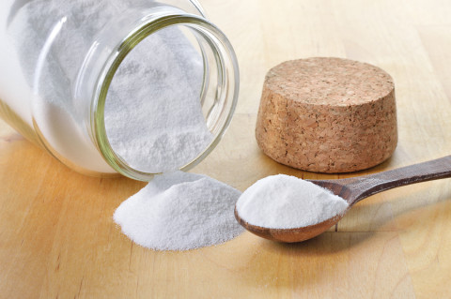

Recommended Dosage for Baking Soda
Recommended dosages from the Arm and Hammer Company for colds and influenza date back to 1925. The company broke the doses up into a three-day period.
The first day consists of six doses of a half-teaspoon of baking soda in a glass of cool water, at about two-hour intervals.
On the second day, the company advises that the individual take four doses of a half-teaspoon of baking soda in a glass of cool water, at the same intervals.
The third day includes two doses of a half-teaspoon of baking soda in a glass of cool water, morning and evening, and thereafter a half-teaspoon of baking soda in a glass of cool water each morning until the cold or flu symptoms are cured.
If you are using baking soda to reduce acidosis (a high level of acid in the body) induced by the diet or the aging process, the recommended dose is five grams daily. If you are using baking soda to treat a medical condition, and it has been more than two weeks, it’s a good idea to see your doctor to be sure that you can continue self-medicating.
Some doctors are using baking soda to treat yeast infections and even cancer. There is not enough research to prove that baking soda is an effective tool for treating cancer patients, but some doctors are using this alternative medicine. In these cases, baking soda is given via the mouth or into a vein. It’s also given intra-arterially (into an artery supplying blood to the tumor) and is sometimes given as a solution directly through the windpipe and into the lungs to treat lung cancer. (3)

Baking Soda Side Effects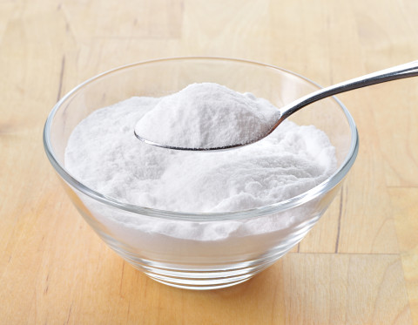
Using baking soda on the skin or body is safe and nontoxic. Consuming baking soda orally is also safe, but don’t exceed the recommended dose. Too much baking soda can upset the body’s acid-base balance; it can also cause nausea and diarrhea when used in excess; it may also cause stomach cramps and an increase in thirst. (4)
Because baking soda is high in sodium — 1,259 milligrams in one teaspoon — high doses aren’t safe, for such doses can raise your blood pressure and cause swelling. In severe cases, it can overload circulation and lead to heart failure. People who consume too much baking soda have reportedly developed blood chemistry imbalances and heart malfunction (ineffective pumping). (5)
If you have edema, liver disease, kidney disease or high blood pressure, you should avoid taking baking soda internally. You should also refrain from consuming baking soda if you are pregnant or breastfeeding. Do not allow children under the age of five to consume baking soda.
If you are on prescription drugs, consult your doctor before consuming baking soda, and make sure you speak to your doctor about drinking baking soda if you are on a sodium-restricted diet.
Some products that may interact with baking soda include aspirin and other salicylates, barbiturates, calcium supplements, corticosteroids, medications with a special coating to protect the stomach, lithium, quinidine, and diuretics.

