3 foods linked with depression
Keep in mind that eating a small portion of any one food is unlikely to raise depression risk, but it's best to avoid overindulgence.
By: Deborah Enos, LiveScience
Mon, Dec 09, 2013 at 01:34 PM

Photo: LoloStock/Shutterstock
It's no secret that we tend to eat a little more around the holidays. And with all the hustle and bustle of the season, many of us have trouble finding time to make healthy choices.

That may be why it's nearly impossible to secure a treadmill at the gym in January — our resolutions are a reflection of our guilt. We know why we tend to eat poorly. But could our food choices be leading to something other than an expanding waistline?

If our poor choices become a habit, certainly. According to recent studies, it's possible that eating certain foods is associated with depression.

Here are three foods you may want to avoid in excess this holiday season, and beyond. [7 Holiday Stress Busters]

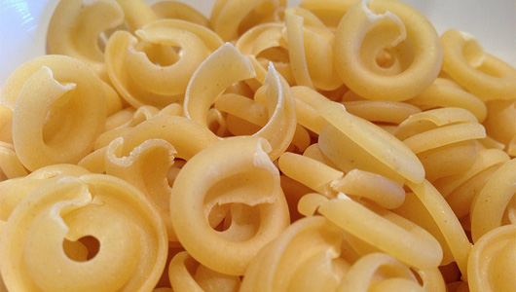
Photo: Guy Renard 25/Flickr

Refined Grains: Pasta is a quick meal, great for those busy nights when you have to spend most of your time shopping, baking or wrapping. But, it may not be a good meal to have every night.

Pasta, white rice and bagels are all foods that have been identified as inflammatory and have been linked to depression in women ages 50 to 77, according to an October 2013 study in the journal Brain, Behavior and Immunity.

In the study, researchers looked at the eating habits of more than 40,000 women, who didn't have depression at the study's start. They found that those who consumed inflammatory foods regularly were more likely to suffer from depression by the end of the study.

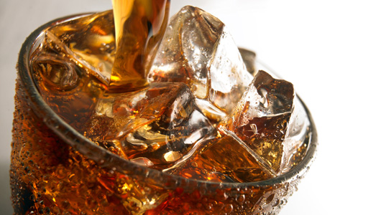
Photo: LI CHAOSHU/Shutterstock

Soft Drinks: As you're buzzing around from store to store, how will you replenish lost fluids? It's all too easy to grab a cola on-the-go, but the same study in Brain, Behavior and Immunity study indicated that soft drinks as part of a regular diet may also contribute to depression. So, if soda is your go-to drink when you're thirsty, it may be time to rethink that strategy.

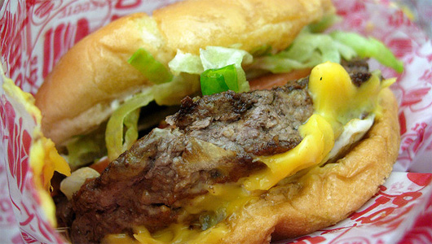
Photo: wEnDaLicious/Flickr

Fast Food: People who eat fast food are 51 percent more likely to develop depression than those who don't, according to a 2012 study in the journal Public Health Nutrition. This includes commercial baked goods, hamburgers, hot dogs and pizza, the researchers said.

Keep in mind that eating a small portion of any one food is unlikely to raise depression risk, so don't worry if you've just eaten your first heaping bowl of pasta in ages, or had the very occasional fast food burger. On the other hand, if this list describes three of your basic food groups, you may benefit from a drastic dietary adjustment.

Healthy Bites appears weekly on LiveScience. Deborah Herlax Enos is a certified nutritionist and a health coach and weight loss expert in the Seattle area with more than 20 years of experience. Read more tips on her blog, Health in a Hurry!
Read more: http://www.mnn.com/food/healthy-eating/stories/3-foods-linked-with-depression#ixzz3BlIFGkf6

