15 Brain Foods to Boost Focus and Memory
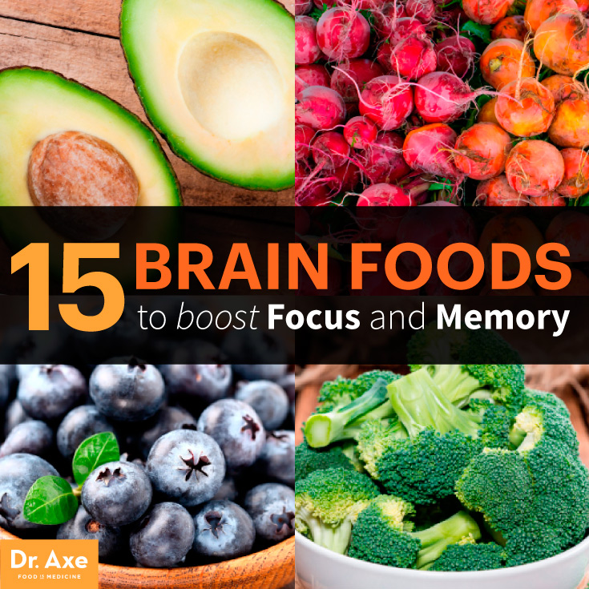
What does the food you eat have to do with how your brain functions? Turns out an awful lot. While we’ve always known that what we eat affects our bodies and how we look, scientists are also learning more and more that what we eat takes a toll on our brains. Yes, brain foods matter (especially for our gray matter).
See, our bodies don’t like stress. Who does? When we’re stressed out — whether it’s physical, like someone jumps out at you from a dark alley, or mental, like you have a major project due at work — our bodies release inflammatory cytokines. (1)
These little chemicals prompt the immune system to kick in and fight back against the stress through inflammation, as though stress is an infection. While inflammation helps protect us against illnesses and repairs the body when you do something like cut yourself, chronic inflammation is a different animal. It’s been linked to autoimmune diseases like multiple sclerosis, anxiety, high blood pressure and more. (2)
But what does this all have to do with food? Our gut helps keep our body’s immune responses and inflammation under control. Additionally, gut hormones that enter the brain or are produced in the brain influence cognitive ability, like understanding and processing new information, staying focused on the task at hand and recognizing when we’re full. (3)
Plus, brain foods rich in antioxidants, good fats, vitamins and minerals provide energy and aid in protecting against brain diseases. So when we focus on giving our bodies whole, nutritious foods benefiting both the gut and the brain, we’re actually benefiting our minds and bodies while keeping them both in tip-top shape.
Of course, some foods are better for your brain than others. I’ve rounded up 15 brain foods you should be eating to feed both your mind and body. With a mix of fruits, veggies, oils and even chocolate (yes, chocolate!), there’s something to please everyone!

Get Healthy, Top to Bottom, with These 15 Brain Foods
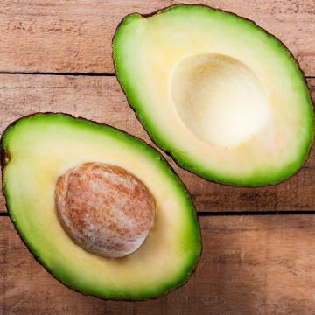

1. Avocados
This fruit is one of the healthiest ones you can consume and one of my all-time favorites. While avocados often get a bad rep because of their high fat content, it’s important to note that these green powerhouses are packed with monosaturated fats or the “good” kind, keeping blood sugar levels steady and your skin glowing.

Containing both vitamin K and folate, avocados help prevent blood clots in the brain (protecting against stroke) as well as help improve cognitive function, especially both memory and concentration.
They’re also rich in vitamin B and vitamin C, which aren’t stored in your body and need to be replenished daily. Plus, they have the highest protein and lowest sugar content of any fruit. Not too shabby! Avocados’ creamy texture makes them a smart addition to smoothies and a replacement for fats in baked goods, or try these brain foods in one of these 50 amazing and easy avocado recipes.
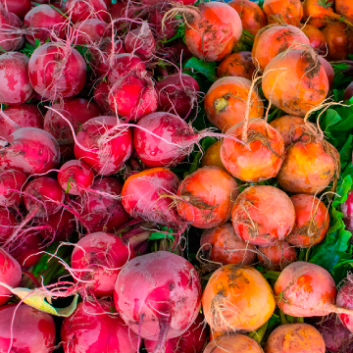

2. Beets
It might be their funny shape or memories of bad recipes eaten during childhood, but beets seem to be an intimidating food for many people, even vegetable lovers. That’s a shame, because these root vegetables are some of the most nutritious plants you can eat — they’ve even earned a spot on my healthy foods shopping list.
They reduce inflammation, are high in cancer-protecting antioxidants and help rid your blood of toxins. The natural nitrates in beets actually boost blood flow to the brain, helping with mental performance. Plus, during tough workouts, beets actually help boost energy and performance levels. I love them roasted or in salads — try my sweet potato beet hash or beet and goat cheese salad for some creative new ways to eat this brain food.
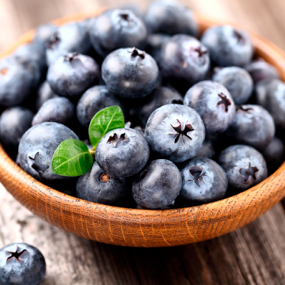
3. Blueberries
Proving that great things do come in small packages, blueberries are a fruit I try to eat daily. That’s because they’ve got so many great health benefit while tasting like an all-natural candy!
For starters, it’s one of the highest antioxidant-rich foods known to man, including vitamin C and vitamin K and fiber. Because of their high levels of gallic acid, blueberries are especially good at protecting our brains from degeneration and stress. Get your daily dose of brain berries in an omega blueberry smoothie, pumpkin blueberry pancakes or in a healthy blueberry cobbler.
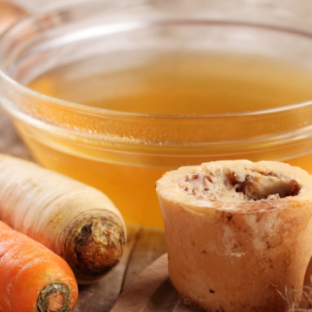
4. Bone Broth
Bone broth is the ultimate food for healing your gut and, in turn, healing your brain. This ancient food is full of health benefits, ranging from boosting your immune system, overcoming leaky gut, improving joint health and overcoming food allergies.
Its high levels of collagen help reduce intestinal inflammation, and healing amino acids like proline and glycine keep your immune system functioning properly and help improve memory. Bone broth is what I prescribe most frequently to my patients because it truly helps heal your body from the inside out. You’ll also be surprised at how simple and economical it is to make at home with my beef bone broth recipe.
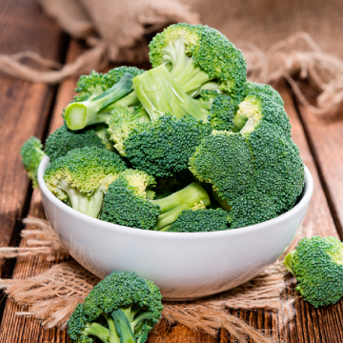

5. Broccoli
Your mom got it right when she told you to eat your broccoli. It’s one of the best brain foods out there. Thanks to its high levels of vitamin K and choline, it will help keep your memory sharp. (4)
It’s also loaded with vitamin C — in fact, just one cup provides you with 150 percent of your recommended daily intake. Its high-fiber levels mean that you’ll feel full quickly, too. If you’ve only chowed down on overcooked, tasteless broccoli, you’ll love my crockpot beef and broccoli, creamy broccoli soup and broccoli pesto dip — they’ll turn you into a broccoli lover fast!
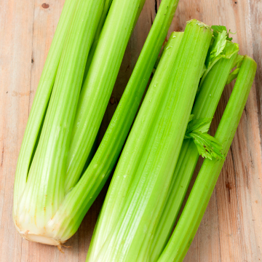

6. Celery
For a vegetable with such few calories (just 16 per cup!), celery sure does offer a lot of benefits. Its high levels of antioxidants and polysaccharides act as natural anti-inflammatories and can help alleviate symptoms related to inflammation, like joint pain and irritable bowel syndrome.
Because it’s so nutrient-dense — packing loads of vitamins, minerals and nutrients with very little calories — it’s a great snack option if you’re looking to shed pounds. And while we often eat celery stalks, don’t skip the seeds and leaves; both provide extra health benefits and taste great in things like stir fries and soups. Not sure where to begin with eating more celery? Try my easy ants on a log or refreshing super hydrator juice recipes.


7. Coconut Oil
Ahh, coconut oil, one of the most versatile — and good for you — foods out there. With 77 coconut oil uses and cures, there’s almost nothing that coconut oil can’t help.
And when it comes to your brain, it’s full of benefits, too. Coconut oil works as a natural anti-inflammatory, suppressing cells responsible for inflammation. It can help with memory loss as you age and destroy bad bacteria that hangs out in your gut. (5) Get your dose of coconut oil in this baked grouper with coconut cilantro sauce or coconut crust pizza.
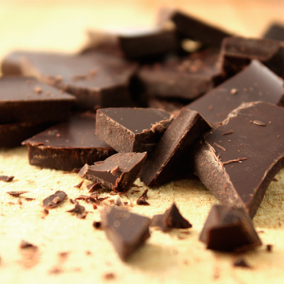

8. Dark Chocolate
Not all chocolate is created equal; in fact, dark chocolate can actually be good for you! Chocolate is chockfull of flavonols, which have antioxidant and anti-inflammatory properties. They can also help lower blood pressure and improve blood flow to both the brain and heart.
But don’t go wild munching on Hershey’s Kisses just yet. Most of the chocolate you see on supermarket shelves is highly processed with few benefits. The rule of thumb is the darker the chocolate, the more health benefits.
Skip milk and white chocolates and opt for a minimally processed dark chocolate with at least 70 percent of cocoa. This ensures you’ll get your choco fix and its brain benefits! Satisfy your sweet tooth with these dark chocolate almond butter cookies or chocolate-covered berries.
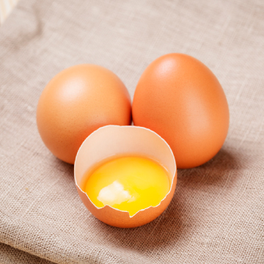

9. Egg Yolks
On the nutritional naughty list for years, egg yolks are finally experiencing their well-deserved day in the sun. If you’ve been eating only egg whites, the yolk’s on you. Yolks contain large amounts of choline, which helps in fetal brain development for pregnant women. It also breaks down bethane, a chemical that produces hormones related to happiness. That’s right, eggs can make you happy! (6)
If you’ve kept away from eating eggs whole because of cholesterol concerns, there’s good news. Studies show that eating eggs had no effect on the cholesterol levels of healthy adults and might, in fact, help raise good cholesterol levels.
It’s also one of the most inexpensive sources of protein out there; just be sure you’re buying organic, free-range eggs. Need some egg-spiration? I love these baked eggs and spinach and breakfast salmon egg bake. For even more ideas, try whipping up one of these 28 delicious egg recipes.
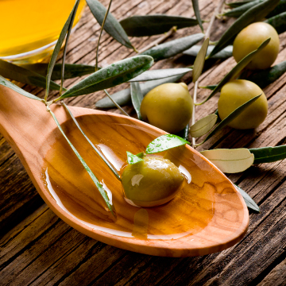

10. Extra Virgin Olive Oil
Real extra virgin olive oil is truly a brain food. Thanks to the powerful antioxidants known as polyphenols that are found in the oil, including EVOO in your diet may not only improve learning and memory, but also reverse the age- and disease-related changes. (7) The oil also helps fight against ADDLs, proteins that are toxic to the brain and induce Alzheimer’s. (8)
As great as extra virgin olive oil is, remember that it’s not a good option for cooking, as it hydrogenizes and begins decomposing at high temperatures. The best way to get your fill is by eating it cold or at room temperature. I love extra virgin olive oil as part of zucchini noodles with marinara sauce and quinoa tabouli salad.
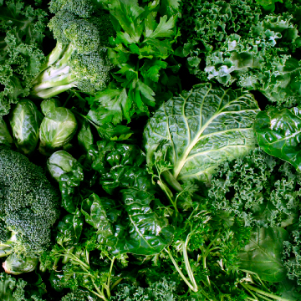

11. Green, Leafy Vegetables
It turns out that Popeye was onto something with his spinach obsession. Getting regular helpings of leafy green brain foods — like kale, Swiss chard and romaine lettuce — can help keep dementia at bay according to new research. (9)
In the study, which evaluated the eating habits and mental ability of more than 950 older adults for an average of five years, those adults who ate a serving of leafy green veggies once or twice a day experienced slower mental deterioration than those who ate no vegetables, even when factors like age, education and family history of dementia were factored in.
Green, leafy vegetables are also loaded with vitamins A and K (just one cup of kale has more than 684 percent of your recommended daily serving!), which help fight inflammation and keep bones strong. Reap the benefits of these brain foods with a mango walnut spinach salad or kale chips.
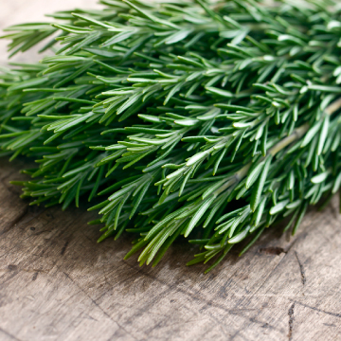

12. Rosemary
We already knew that rosemary oil has a variety of benefits, but did you know that the herb does, too? Carnosic acid, one of the main ingredients in rosemary, helps protect the brain from neurodegeneration. It does this by protecting the brain against chemical free radicals, which are linked to neurodegeneration, Alzheimer’s, strokes and normal aging in the brain. (10)
It also helps protect eyesight from deteriorating, thanks to its high levels of antioxidants and anti-inflammatory properties. (11) Get your servings of fresh rosemary with these sweet potato rosemary fries and maple-glazed rosemary carrots.
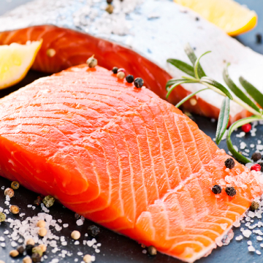

13. Salmon
If you like seafood, get excited, because salmon is one of the most nutritious, brain food-friendly foods out there! It’s packed with omega-3 fatty acids to help keep your brain running smoothly — goodbye, brain fog — and improve memory.
If you have kids, feeding them salmon can help prevent ADHD by improving their focus. And these same fatty acids can also help prevent cancer and kill tumors — not bad for a four-ounce serving of fish!
Please note that these benefits are for Alaskan wild-caught salmon — farm-raised and regular wild-caught salmon can be filled with mercury and toxins. Enjoy it in these salmon cakes or homemade smoked salmon sushi bowl.
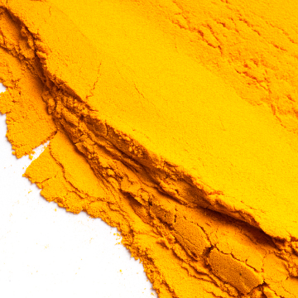

14. Turmeric
Isn’t it great when a simple spice has amazing health benefits? That’s the case with turmeric, an ancient root that’s been used for its healing properties throughout history. Thanks to curcumin, a chemical compound found in turmeric, the spice is actually one of the most powerful (and natural) anti-inflammatory agents.
Turmeric also helps boost antioxidant levels and keep your immune system healthy, while also improving your brain’s oxygen intake, keeping you alert and able to process information. Talk about a super spice! Start your day with this brain food and make my turmeric eggs and turmeric tea.
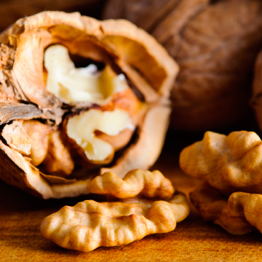

15. Walnuts
It turns out that eating walnuts can keep you from going nuts. Just munching on a few walnuts a day can improve your cognitive health. (12) Their high levels of antioxidants, vitamins and minerals also improve mental alertness. The vitamin E in the nuts can also help ward off Alzheimer’s.

